Ethel (Cureau) Robottom
February 15, 1920 – May 18, 2014

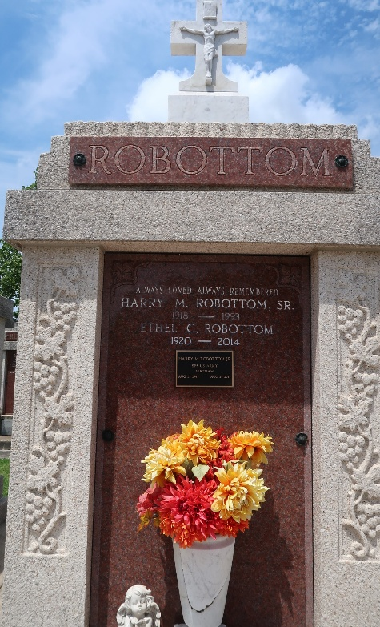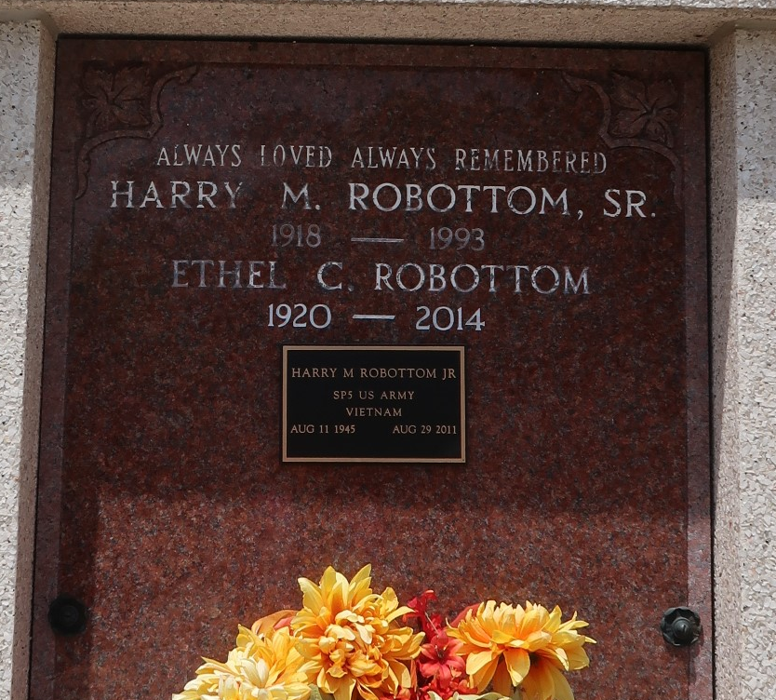

ETHEL C. ROBOTTOM on Sunday, May 18, 2014 at Ochsner of Kenner, Kenner, LA.
Daughter of the late Aurelian and Leah Perrilloux Cureau. Wife of the late Harry M. Robottom, Sr. Mother of Leah (Emile) Rousseve, Darcelle (Eljerry) Collins, Chenelle (Theodore) Collins, Jr., Hernendez (Natalie) Robottom and the late Harry M. Robottom, Jr. Sister of the late Gladys C. Duhe, Eunice C. Leche and Leroy Cureau. Also survived by 10 grandchildren, 6 great grandchildren, 7 great great grandchildren and a host of nieces, nephews, other relatives and friends. Age 94 years. A native and resident of Reserve, LA.
Relatives and friends of the family, also priest and parishioners of Our Lady of Grace Catholic Church and all neighboring churches and employees of Robottom Mortuary, Marathon Petroleum Company, and proprietors and employees of surrounding funeral homes are invited to attend the Funeral Mass at Our Lady of Grace Catholic Church, 772 Highway 44, Reserve, LA on Thursday, May 22, 2014 at 10:00 AM. Father Christopher Amadi, Celebrant Interment St. Peter Cemetery, Reserve, LA. Visitation at the above named church from 8:00 AM until Mass time. Recitation of the rosary at 9:00 AM. SERVICED BY ROBOTTOM

The Times-Picayune, New Orleans, Louisiana
May 19 to May 21, 2014

