Harry M. Robottom Jr
August 11, 1945 – August 29, 2011

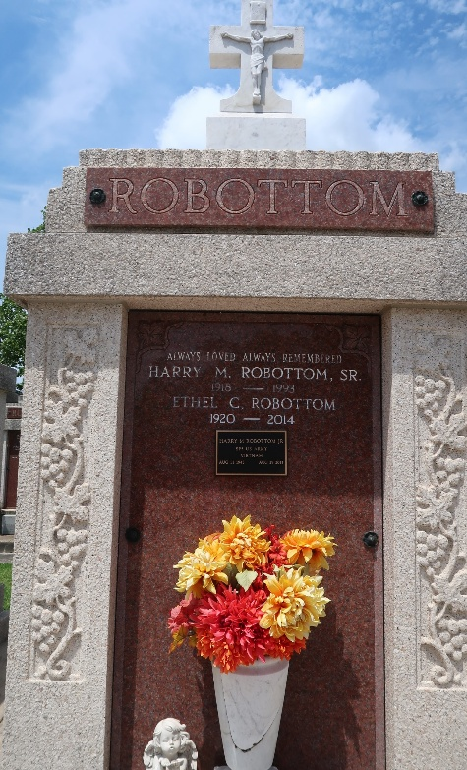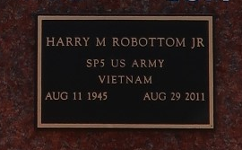

Harry M. Robottom, Jr., (Rock) on Monday, August 29, 2011 at his home in Reserve, LA.
Son of Ethel C. Robottom and the late Harry M. Robottom, Sr. Father of Kya Renette Robottom. Brother of Leah (Emile) Rousseve, Darcelle (Eljerry) Collins, Chenelle (Theodore) Collins, Jr. and Hernendez (Natalie) Robottom. Also survived by a host of nieces, nephews, other relatives and friends. Age 66 years. A native and resident of Reserve, LA.
Relatives and friends of the family, also priest and parishioners of Our Lady of Grace Catholic Church, all neighboring churches, and employees of Robottom Mortuary, Marathon Oil Co., and St. John the Baptist Parish Government are invited to attend the Mass of Christian Burial at Our Lady of Grace Catholic Church, 772 Highway 44, Reserve, LA on Friday, September 2, 2011 at 11:00 AM. Father Joseph Rodney, Celebrant. Interment St Peter Cemetery, Reserve, LA. Visitation at the above named church from 9:00 AM until Mass time. SERVICED BY ROBOTTOM

The Times-Picayune, New Orleans, Louisiana
September 1, 2011

