Harry Marcellus Robottom Sr.
January 16, 1918 – July 20, 1993

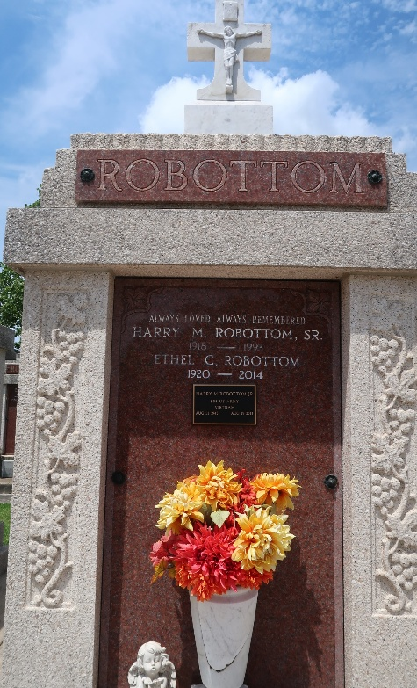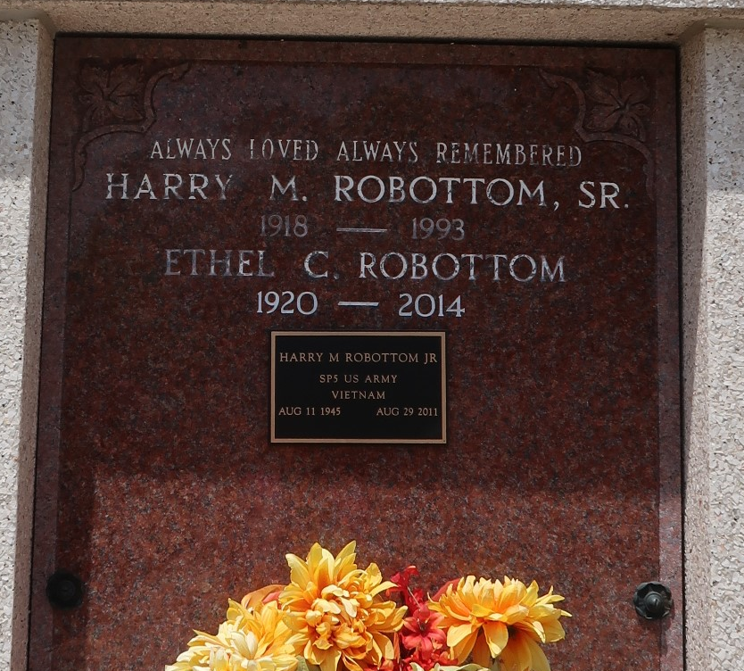

Harry Marcellus Robottom from tree Rousseve Robottom Family Tree

Birth 16 Jan 1918 Hahnville, St Charles, Louisiana, USA
Residence 1930 St Charles, Louisiana, USA
Death 20 Jul 1993 Reserve, St John the Baptist, Louisiana, USA
Father Henry Robottom (1883-1956)
Mother Odelia Ferrand (Born 1887)
Spouse Ethel Catherine Cureau (1920-2014)
239 People 4 Records 8 Sources

