Frances (Falgoust) Roccaforte
January 22, 1927 – October 17, 2008

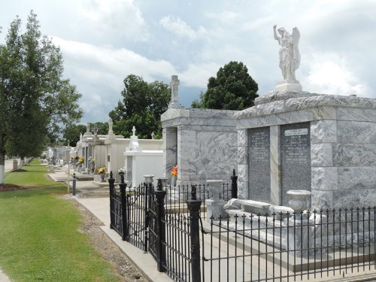

Frances 'Ginick' Falgoust Roccaforte on Friday, October 17, 2008 at 7:00 PM.
Beloved wife of the late Frank Roccaforte. Mother of Gwen Entremont and husband Glynn, Barry Roccaforte and wife Tanya and Susie Louque and husband Mark. Grandmother of Jarrett and Nicole Entremont, Aimee Bourgeois, Mike and Jeff Roccaforte, Mark Louque, Jr. and Michelle Roussel. Grandmother of Jarrett and Nicole Entremont, Aimee Bourgeois, Mike and jeff Roccaforte, Mark Louque, Jr. and Michelle Roussel. Also survived by 9 great-grandchildren.
Daughter of the late Armand and Bernice Falgoust. Sister of Lotsy Haydel, Shirley Mae Miano, Beryl LeBouef and the late Marcel and Pete Falgoust
and Audrey Monica.
She was the St. Hubert Catholic Church organist and religion teacher. Age 81 years. A native and resident of Garyville, LA.
Relatives and friends, also members of Ladies Auxiliary Post 8167, Ladies Altar Society, Catholic Daughters and Home Demonstration are invited to attend services.
Visitation at St. Hubert Catholic Church, Garyville, La. On Tuesday, October 21, 2008 from 9:00 AM to 12:00 noon. Followed by Religious Services at St. Hubert Church at 12:00 noon. Burial in St. Peter Cemetery, Reserve, La.
In lieu of flowers, donations preferred to the American Cancer Society. Arrangements by Millet-Guidry Funeral Home, LaPlace, LA.
Times Picayune, New Orleans, Louisiana
October 19, 2008

