Frank Roccaforte
1878 – November 7, 1952

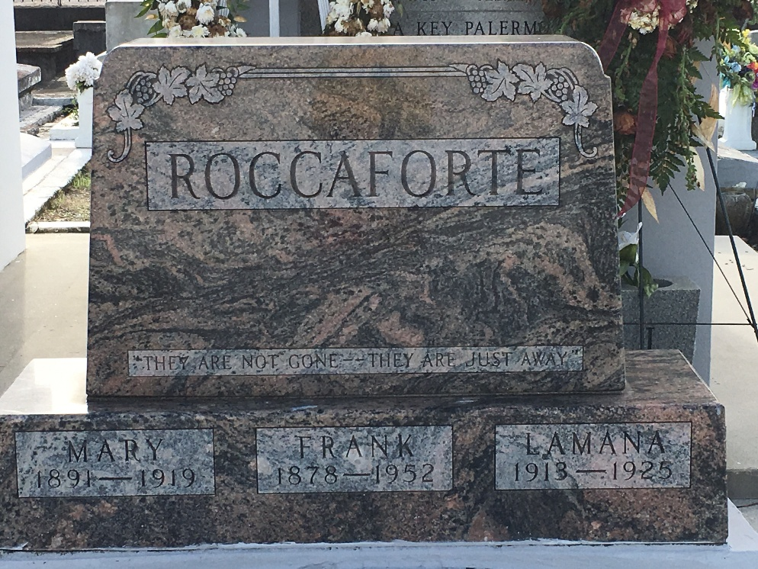
Photo by Team T-Lo

ROCCAFORTE – At the residence of Morris Landry in Gramercy, La., on Friday, November 7, 1952, at 6 o’clock a.m., Frank Roccaforte, husband of Katie Tramonte and of the late Mary Palermo, father of Mrs. Rosie Tramonte, Mrs. Sara Bueche, Mrs. Louise Accardo, Mrs. Marie Landry and of the late Lamana Roccaforte; stepfather of Mrs. Vita Rebaldo, Mrs. Anna Miano, Mrs. Lena Miano, Mrs. Virginia Maurain, Anthony, Charlie and Louis Tramonte; brother of Louis Lamana, Benny Roccaforte, Mrs. Esther Lacara, Mrs. Rosie Arrillo and of the late Anthony Roccaforte, Mrs. Phyllis Monica and Miss Louise Roccaforte.
Relatives and friends of the family are invited to attend the funeral which will take place on Saturday, November 8, 1952 from the Alexander Funeral Home, Lutcher, La., at 3 o’clock p.m., followed by religious services at the St. Joseph church, Paulina, La. Interment in St. Petr’s cemetery, Reserve, La.
Times Picayune, New Orleans, Louisiana
Saturday, November 8, 1952

