Lamana A. ‘Lonnie’ Roccaforte
February 3, 1947 - March 15, 2009

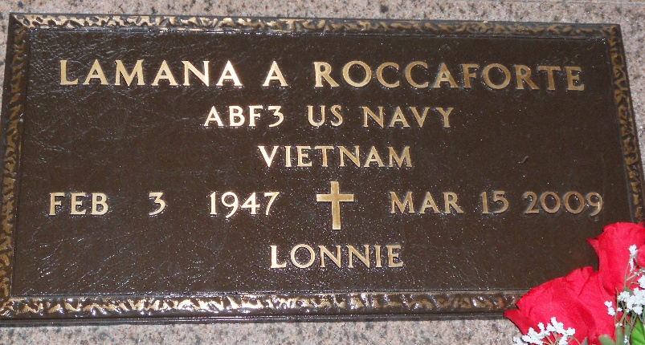
Photo by Team T-Lo

Lamana (Lonnie) Roccaforte on Sunday, March 15, 2009 at 7:00 pm.
Beloved husband of Janice Falgoust Roccaforte. Father of Christa St. Pierre, Scott and Randy Roccaforte. Father-in-law of Quincee Roccaforte and the late Darren St. Pierre. Grandfather of Brooke St. Pierre. Son of the late Lamana and Agnes Roccaforte. Son-in-law of Marion Falgoust and the late Loisel Falgoust. Brother of Brent and Vita Roccaforte. Age 62 years. A native and resident of Garyville, La.
Relatives and friends, also employees of DuPont are invited to attend services. Visitation at Millet-Guidry Funeral Home, 2806 W. Airline Hwy, LaPlace, La, on Wednesday, March 18, 2009 from 5:00 pm to 9:00 pm and on Thursday from 8:00 am to 9:30 am. Followed by a Mass of Christian Burial at St. Hubert Catholic Church, Garyville, La. at 10:00 am. Burial in St. Peter Cemetery, Reserve, La.
Times Picayune, New Orleans, Louisiana
March 18, 2009

