Karen Ann Rome
December 18, 1947 – October 2, 1989

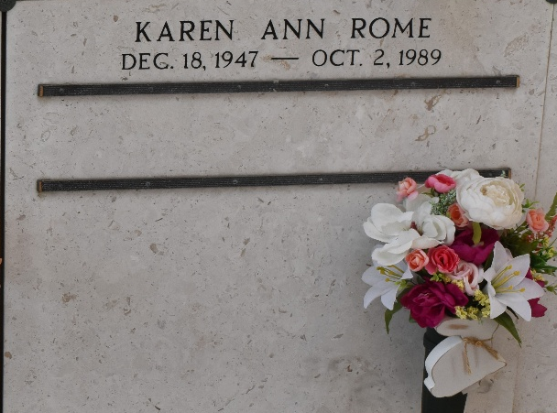

Karen Ann Rome on Monday, October 2, 1989 at 8:30 p.m.
Beloved daughter of Rita Salzer Rome and Thomas Rome. Sister of Paulette Kilburn, Lorraine Tamburello, Renee Natell, Thomas Rome, Jr., Mary Lynne Rome, April Wehrs and Nichole Gatewood. Granddaughter of Mabel Salzer. Also survived by nieces and nephews. Age 41 years. A native and resident of Laplace, LA.
Relatives and friends of the family are invited to attend the funeral service at Millet-Guidry Funeral Home, 2806 West Airline Hwy., LaPlace, La., on Wednesday, October 4, 1989, followed by religious service at St. Joan of Arc Catholic Church, Laplace, LA at 10:00 a.m. Interment in St. Peter Cemetery, Reserve, LA. Friends may call from 5:00 p.m. until 10:00 p.m. on Tuesday, October 3, 1989 and from 8:00 a.m. until service on Wednesday.
Times Picayune, New Orleans, Louisiana
October 4, 1989

