Rita Mae (Salzer) Rome
April 1, 1928 – February 15, 1994

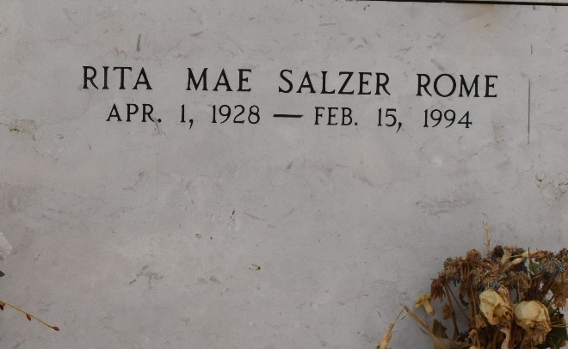

Rita Mae Rome on Tuesday, February 15, 1994 at 5:26 p.m.
Beloved wife of Thomas Rome, Sr. Mother of Paulette Kilburn, Lorraine Tamburello, Renee Natell, Thomas Rome, jr., Mary Lynne Rome, April Wehrs, Nicole Gatewood and the late Karen Ann Rome. Daughter of Mabel Salzer and the late Alfred Salzer, Sr. Sister of Alfred Salzer, Jr., Carol Beckleheimer, Jackie Hymel, Iris Waguespack, Sherian Soloman, Adrian Bettevy, and late Rose Decker and Michael Salzer. Age 65. Also survived by 11 grandchildren. A native of New Orleans, and a resident of LaPlace for the past 47 years.
Relatives and friends of the family are invited to attend the funeral. Services at Millet-Guidry Funeral Home, 2806 West Airline Hwy., LaPlace, La., on Friday, February 18, 1994 followed by religious service at St. Joan of Arc Catholic Church, Laplace, LA at 11:00 a.m. Interment in St. Peter Cemetery, Reserve, LA. Friends may call from 5:00 p.m. until 10:00 p.m. on Thursday and 8:00 a.m. until services on Friday.
Times Picayune, New Orleans, Louisiana
February 17, 1994

