Sterling Joseph Rome
March 31, 1920 – December 4, 1944

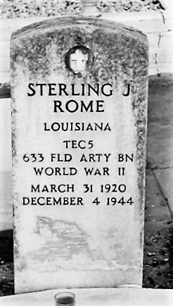

Sterling J Rome
in the U.S., Headstone Applications for Military Veterans, 1861-1985

Name Sterling J Rome
Birth Date 31 Mar 1920
Service Number 34 154 513
Service Branch US Army
Unit 633rd Field Artillery. Bn A/S Field Artillery
Company 633rd Battary A
Enlistment Date 28 Nov 1941
Death Date 4 Dec 1944
Cemetery St Peter's Cemetery
Cemetery Location Reserve, Louisiana, USA
**

Louisiana, U.S., State Birth Records, 1911-1923

Name Joseph Sterling Rome
Gender Male
Birth Date 31 Mar 1920
Birth Place Vacherie, St. James, Louisiana, USA
Legitimacy Yes
Certificate Number 12750-13261
Father Jean Rome, age 34
Mother Elucia Murry Rome, age 30, 6 of 6 children living

