Oscar Henry Ross Jr.
Unknown – September 10, 2008

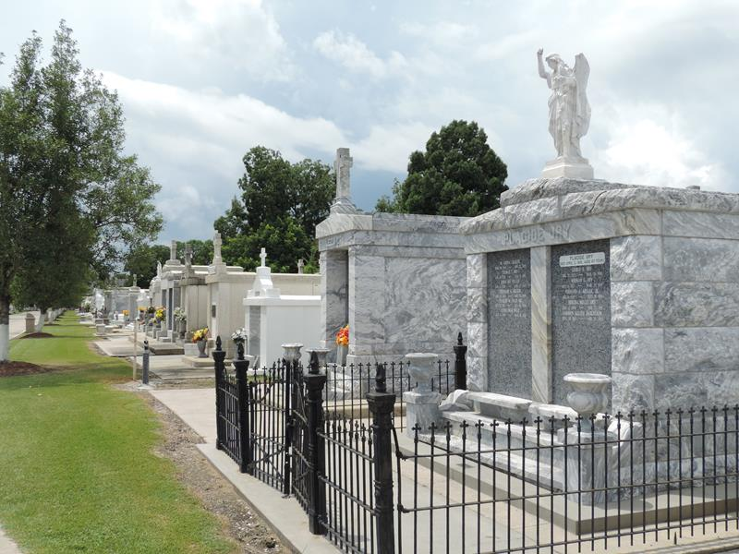

Oscar Henry "Bro Ross" Ross, Jr. departed this earthly life on Wednesday, Sept. 10, 2008 at Seton Medical Center of Austin, TX.
Son of the late Edna F. and Oscar H. Ross, Sr. Beloved father of Ray Mitchell of Gonzales, La., Varrel Mitchell of Gevena, Ny., Gina Kirklin (Isadore) of Lutcher, La., Crystal Washington and Crystal Wickliffe (Terrance) of Houston, Tx., Marcys Mitchell of Virginia Beach, VA, Ashley Ross of Austin, Tx., Vickie Ross, Carla Ross, Nikki Rice and Nicholas Rice of Temple, Tx., Cheri Locke, Shameaka Grappe, Alisha Whitehead, Sheila Ross, Justin Ross and Patricia Ross of Killeen, Tx. Loving brother of Carolyn Gardner of Sacramento, Ca., Mary Louise Doris and Vernece Batiste of Garyville, La., Dianne Ross and Barbara Melancon of Laplace, La., Dionne Johnson of Reserve, La., Cheryl Null of Navarre, Fl. and the late Marion Swafford, Varrell and Ricks Ross. Also survived by a host of grandchildren, great-grandchildren, nieces, nephews, other relatives and friends. He was a native of Garyville, La.
Relatives and friends of the family, also Pastors, Officers and Members of Providence II Baptist Church of Montz, La. and all neighboring churches are invited to attend the Funeral Services on Saturday, September 20, 2008 at 10:00 AM at Providence II Baptist Church, 152 Union Ln., Montz, LA. Rev. Donald Brown officiating. Interment in St. Peter Cemetery of Reserve, LA. Visitation will be at the above named church from 9:00 AM until service time. Bardell's Mortuary of Mt. Airy, LA in charge. Information: 985-535-6837

The Times-Picayune, New Orleans, Louisiana
Sep. 19, 2008

