Calvin A. Rousse
March 15, 1937 – August 16, 2012

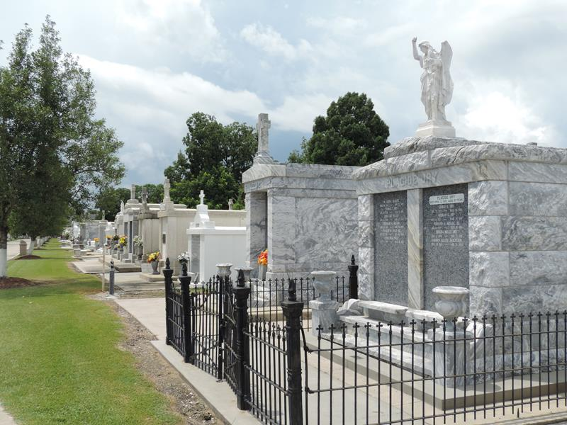
Photo by Mary Agnes Hammett

Calvin A. Rousse passed away on Thursday, August 16, 2012.
Beloved husband of Iris Boudreaux Rousse. Stepfather of Terry Dufresne, Sidney (Skip) Dufresne Jr. (Gwen), Jill Lundin (Rick), Timmy Dufresne and Pat Dufresne. Step-grandfather of Shane Arceneaux, Nicholas and Wendy Waren, Ashley, Rachael, Alex, Angie and Aimee Dufresne. Son of the late Eddie and Antoinette Rousse. Brother of Elvest Rousse, Elaine Ezell, Ruby Callais and the late Carlton Rousse. Age 75. A native of Galliano and resident of Reserve, LA. Formerly employed by Colonial Sugars and a long time member of the Reserve Lions Club.
Relatives and friends are invited to attend services. Visitation at St. Peter Catholic Church, Reserve, LA on Saturday, August 18, 2012 from 9:00 am to 11:00 am, followed by Mass at 11:00 am. Burial in St. Peter Cemetery, Reserve, LA. Arrangements by Millet-Guidry Funeral Home, LaPlace, LA.

The Times-Picayune, New Orleans, Louisiana
Aug. 16 to Aug. 17, 2012

