Blain J. Roussel
September 7, 1962 – April 9, 2021

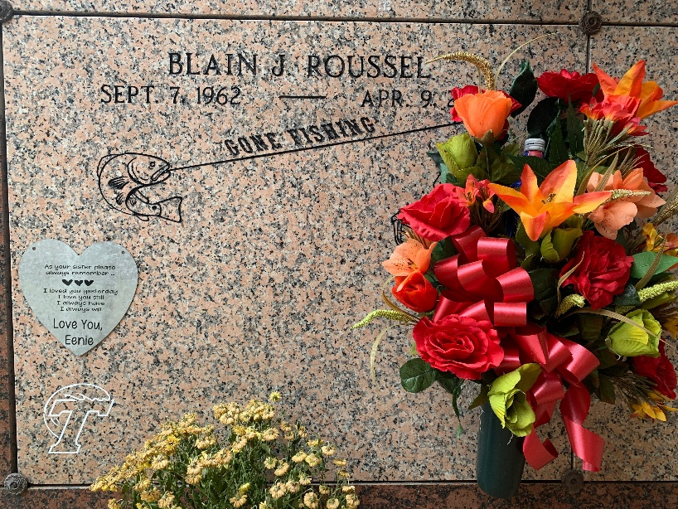
Photo by Team T-Lo

Blain J. Roussel, a resident of Garyville, passed away surrounded by his family on Friday, April 9, 2021 at the age of 58.

He is survived by his wife of 36 years, Stacy Poche Roussel; sons, Cody Roussel (Natalie) and Brye Roussel (Caroline); grandchildren, Emilia Roussel, Nathan Roussel, Evan Roussel and Skylar Roussel; siblings, Leo Roussel Jr., Lynelle Roussel Heikamp and Tiffany Roussel Vicknair.

He is preceded in death by his parents, Leo and Dianne Roussel Sr.

A visitation will be held at St. Peter Catholic Church on Tuesday, April 13, 2021 from 9:00 AM until funeral time. A Mass of Christian Burial will begin at 11:00 AM. Interment will follow in the church cemetery.

The family would like to thank Hospice of Baton Rouge for the care they gave to Blain. Donations can be made to Perry’s Posse.

Rose Lynn Funeral Home, Lutcher, Louisiana

