Brent Peter Roussel Sr.
February 22, 1941 – February 22, 2016

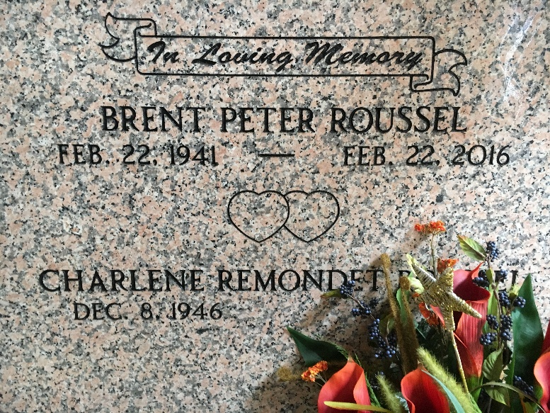
Photo by Team T-Lo

Brent P. Roussel, Sr. passed peacefully at home surrounded by family on Monday, February 22, 2016 at the age of 75. Beloved husband of Charlene Remondet Roussel. He was a native of Reserve and a lifelong resident of St. John Parish. Graduate of Leon Godchaux High School, Southwest Mississippi Junior College and Southeastern Louisiana University.
He was preceded in death by his parents, Robert Roussel, Sr. and Myrza Brignac Roussel; siblings, Norris Roussel, Esther Roussel Heltz, Robert Roussel, Jr., Ruby Roussel, Emma Roussel Laiche, Marie Roussel Klibert, Russell Roussel and William Roussel; son, Joseph Gerard Roussel; and 2 great grandchildren.
He is survived by his wife, Charlene Remondet Roussel; siblings, Paul Roussel, Marian Roussel Entremont, Myrza Roussel Ruiz and Terry Roussel; children, Brent P. Roussel, II, Robert Roussel, Sean Roussel and Lafayette Duhe; 7 grandchildren and 3 great grandchildren.
Relatives and friends are invited to attend the Funeral Mass at St. Peter Catholic Church, 1550 Hwy 44, Reserve on Thursday, February 25, 2016 at 11:00 a.m. Visitation will begin in church at 9:00 a.m. Interment in St. Peter Cemetery.
TheAdvocate.com
Feb. 23 to Feb. 25, 2016

