Dorothy Ann (Roddy) Roussel
June 11, 1915 – February 17, 2006

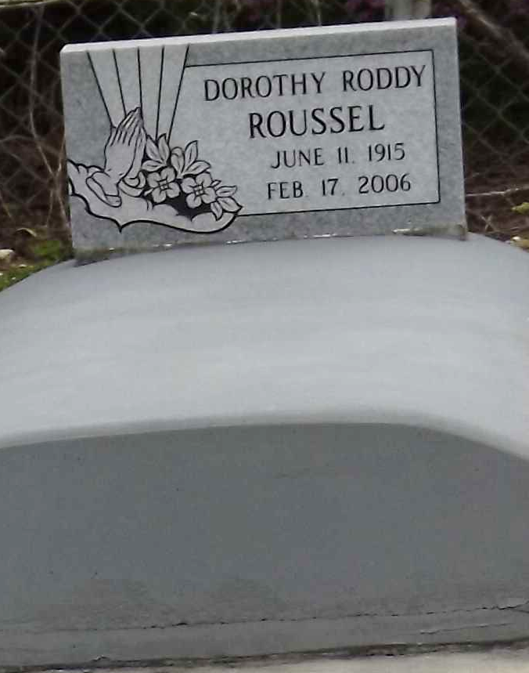
Photo by Mary Agnes Hammett

Dorothy Roddy Roussel, resident of Gramercy for the past 90 years. Graduate of LSU in 1936, and school teacher in Lutcher for 32 years. Died on Friday, February 17, 2006.
Wife of the late Ecton Joseph Roussel. Daughter of the late Yancy Lawrence Roddy and the late Marie Bergeron Roddy. Mother of Kerry Joseph Roussel.
Mother and mother-in-law of Sharon Roussel Payne and Thomas Colwell Payne, and Kevin James Roussel and Jane Millet Roussel. Sister of Symbol Wee Ordeneaux and the late Harry Yancy Roddy, Guy Frank Roddy, Earl Joseph Roddy, Kerman Joseph Roddy. Grandmother of Todd Phillip Roussel and Scott Michael Roussel of Gramercy, Jennifer Roussel Austin of Baton Rouge, LA, Courtney Payne Gupton, Amy Hamilton Payne and Meagan Christine Payne of Norco, LA, Kimberly Ann Payne of New York, NY., Matthew Simon Roussel, Alison Elizabeth Roussel and Adam Christopher Roussel of Gonzales, LA. Great grandmother of Kaleb Michael Roussel, Alexa Elizabeth Roussel, Ashlyn Rae Austin, and Edward Frank Austin, III.
Visitation Monday, February 20, 2006 at 9:00 AM until 11:00 AM. Religious services 11:00 am, Monday, February 20, 2006 at Sacred Heart Church in Gramercy, LA. Burial followed in the St. Peters Cemetery in Reserve, LA.
Dorothy was educated at Lutcher High School graduating in 1932. She then attended Louisiana State University in Baton Rouge, LA where she graduated in 1936 with a Major in English and French and a Minor in History. She began working as a seventh grade teacher in Vacherie for six years. She then began teaching at St. James High School in 1942. Six years later she moved to Lutcher High School and taught until retirement in 1969.
She met Ecton in 1934 at a community dance in Belmont, LA when she was 19 years old. They later married in 1941 and moved into their new home on Airline Avenue in Gramercy. In charge of arrangements: H.C. ALEXANDER OF LUTCHER.
Times Picayune, New Orleans, Louisiana
February 19, 2006

