Dorothy (Klibert) Roussel
February 16, 1926 – July 24, 2020

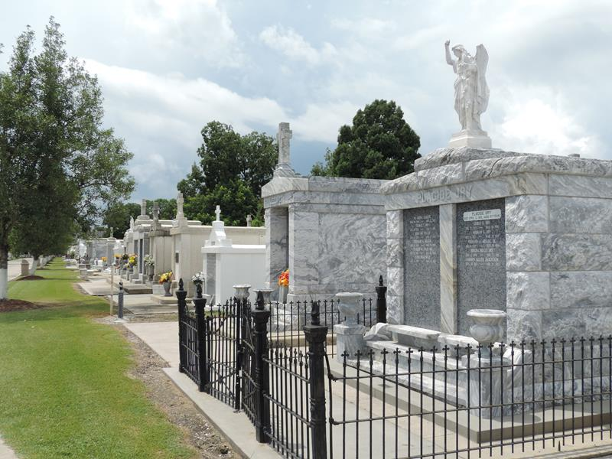

Dorothy “Dot” Roussel, age 94, passed away on July 24, 2020. She was a native of Belmont and resident of Gramercy, LA.
She is survived by her children, Garland Roussel, Jr (Pauline), Kenneth Roussel (Connie), Pam Hearon (Hugh) and Julie Szubinski (Teddy); grandchildren, Amy, Andy (Toni), Preston, Kasey (Michelle), Kendall, Quinn (Trisha), Weylin (Kayla), Bridget (Roger), Damian, and Barrett (Lori); and 19 great-grandchildren.
She is preceded in death by her husband, Garland Roussel Sr.; mother, Armantine Oubre Klibert; father, David Klibert; brothers, Harold Klibert, Allen Klibert; Lloyd Klibert; and sister, Betty Naquin.
A visitation in her honor will be held on Tuesday, July 28, 2020 at Rose Lynn Funeral Home in Lutcher, LA from 9:00 am to 11:30 am. A Mass of Christian Burial will take place at Sacred Heart Church at 12 noon in Gramercy, Louisiana. Burial will follow at St. Peters Cemetery in Reserve, LA.

Rose Lynn Funeral Home, Lutcher, Louisiana

