Ecton Joseph Roussel
June 19, 1913 – July 16, 1995

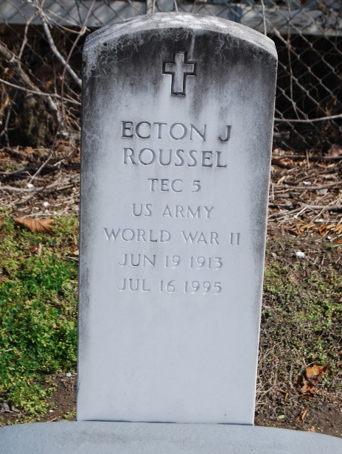
Photo by Kerry Keller

Ecton Joseph Roussel, on Sunday July 16, 1996 at 8:40 A.M. Beloved husband of Dorothy Roddy. Son of the late Ferducie Roussel and the late Elida Poche. Father of Kerry Joseph Roussel, Sharon Roussel Payne, and Kevin James Roussel. Father-in-Law of Thomas Colwell Payne and Jane Millet Roussel. Brother of the late Pearl Roussel Zeller and Clovis (Pete) Roussel. Grandfather of Todd Philip Roussel, Scott Michael Roussel, Jennifer Lynn Roussel, Courtney Brooke Payne, Amy Hamilton Payne, Kimberly Ann Payne, Meagan Christine Payne, Matthew Simon Roussel, Alison Elizabeth Roussel, and Adam Christopher Roussel. Great Grandfather of Kaleb Michael Roussel. A native of St. James Parish for 82 years. Served as a French interpreter for the US command during the D-Day invasion at Normandy with the United States Army during World War II and received the Bronze Star for his service.
Relatives and friends of the family are invited attend the funeral. Services from Alexander Funeral Home, River Road, Paulina on Wednesday, July 19th, 1996 at 10:00 A.M. Followed by a Funeral Mass at Sacred Heart Church in Gramercy Louisiana. Interment in St. Peter's Cemetery in Reserve, Louisiana.

Unknown source

