Gloria Jane (Madere) Roussel
March 22, 1944 – April 15, 2016

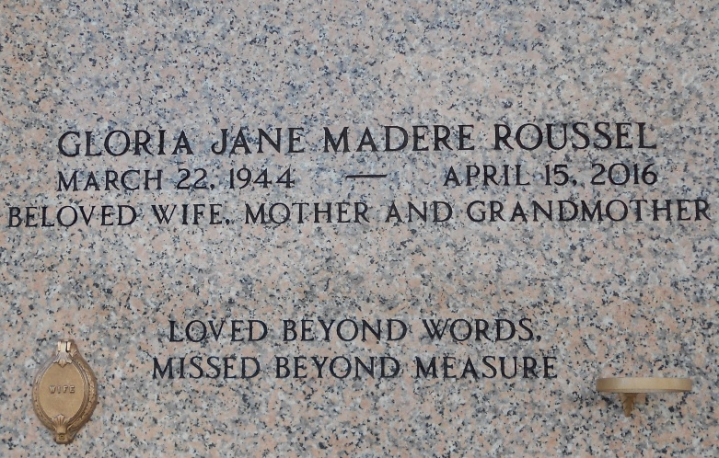
Photo by Team T-Lo

Gloria “Jane” Madere Roussel, 72, a native and resident of Montz, passed away on April 15, 2016.
Jane was the beloved wife of Barry J. Roussel and loving mother of Barry J. Roussel, Jr. (Michelle), Toni Roussel, Joni Roussel (Gary Hartley), Gwen Montalbano (Trey) and Angela Lastrapes (David). She is also survived by 7 grandchildren and 4 great grandchildren.
She was the daughter of the late Clement Madere and Rita Brady Madere. Sister of Elsie Madere, Gail Roberson (Walt), Bryan Madere (Dot) and Keith Madere and the late Marilyn Brady (the late Myron), Neil Madere (Sandra) and Michael Madere.
Relatives and friends of the family are invited to attend the Funeral Mass at St. Joan of Arc Catholic Church, LaPlace, LA on Tuesday, April 19, 2016 at 12:00 p.m. Visitation will begin in the church at 9:30 a.m. until Mass time.
Interment will follow in St. Peter Cemetery.

Millet-Guidry Funeral Home, LaPlace, Louisiana

