Hubert Emile Roussel Jr.
February 4, 1942 – September 24, 2006

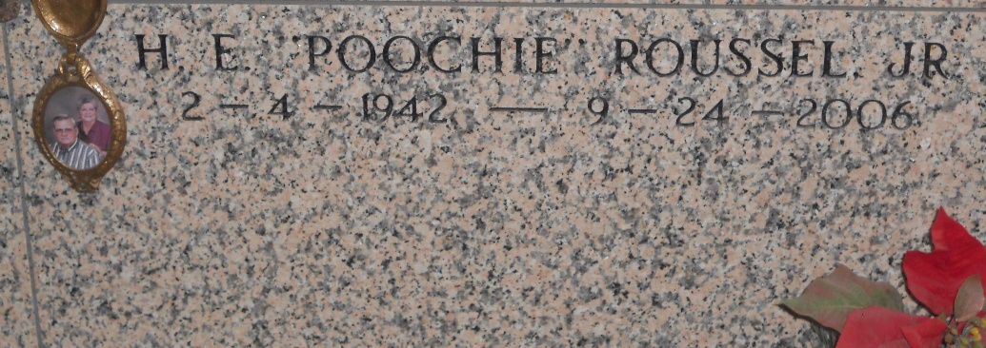
Photo by Team T-Lo

Hubert E. 'Poochie' Roussel, Jr. on Sunday, September 24, 2006 at 11:59 A.M. at his home, Age 64 years. Beloved husband of Joy Ann Matherne Roussel of 44 years.
Along with his wife, he is survived by his sons Randy P. of Decatur, AL, Kevin J. of Reserve, LA. and Craig A. of Mandeville, LA. and daughters-in-law Kerri Montz Roussel and Yvette Tavan Roussel. He leaves behind grandchildren Connor M., Cameron A., Matthew L. and Jessica M. Roussel. He is also survived by his mother, Noelie Zeringue Roussel and two sisters: Barbara R. Robicheaux and Cynthia R. Marse and in-laws Charles Robicheaux, Jean Marse, Gay Nell Matherne Becnel and Walter Becnel, and numerous nieces and nephews.
He is preceded in death by his father H.E. 'Cadie' Roussel, Sr. Mr. Roussel was born and raised in Norco, LA.
He was presently employed for 21 years by the St. Charles Parish Sheriff's Office and spent the last 10 years as bailiff for Judge Emile St. Pierre. Previously he was employed by R.T.L., St. Pierre's Fabrication, K.C.I. and Norco Co-op.
Mass of Christian Burial at 11:00 A.M. on Wednesday, September 27, 2006 at Sacred Heart Catholic Church in Norco, LA. Interment in St. Peter's Catholic Church Cemetery, Reserve, LA. Visitation at Alexander Funeral Home in Norco, LA. from 6:00 P.M. to 9:00 P.M. on Tuesday, and from 8:00 A.M. to 10:45 A.M. on Wednesday. In lieu of flowers, Masses preferred. H.C. ALEXANDER FUNERAL HOME of Norco in charge of arrangements.
Times Picayune, New Orleans, Louisiana
September 26, 2006

