Jacqueline (Jacob) Roussel
May 3, 1935 – October 31, 2021

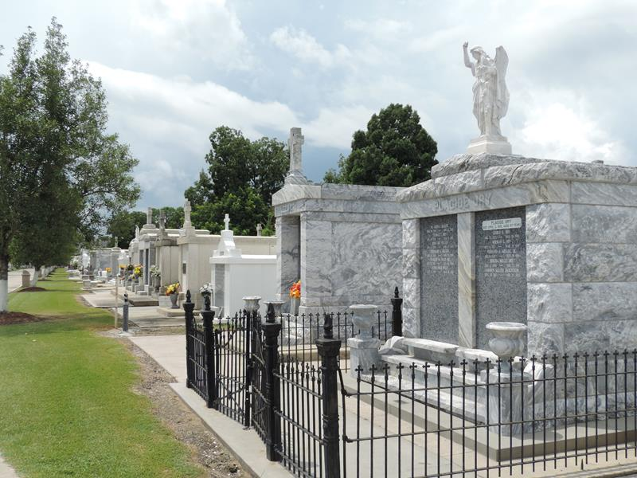

Jacqueline Jacob Roussel passed away on Sunday, October 31,2021, at the age of 86. She was a native of Reserve and longtime resident of LaPlace.
She was the beloved wife of Jessie Roussel who passed away in 2013. Their love was one for the ages and serves as an example to future generations. She is survived by her children; Joelyn Roussel Perkins(Summers), Randy Roussel(Darrelyn Evers), Chris Roussel(Amber Rodrigue), Neil Roussel(Judy Albarado), and "Jay" Roussel (Stacey Larsen). Mawmaw of James Perkins II, Jessica Perkins Clouatre, Jordan Perkins, Randi Roussel Giddings, Ryann Roussel Reesby, Jason Roussel, Jess Roussel, Rene Roussel, Brooke Roussel, Paige Roussel, Emelie Roussel and Jessie Claire Roussel. Great- grandma of Max Perkins, Layla Perkins, Jake Perkins, Keller Clouatre, Rosie Clouatre, Oliver Clouatre, William Clouatre, Jolie Perkins, Jonah Perkins, Rylee Giddings, Joseph Giddings, Arden Reesby, Dawson Roussel, and Alanda Roussel.
Preceded in death by parents, Whitney and Rosie Catoire Jacob and brother, Malcom Jacob. She is survived by her sister, Joycelyn “Peanut” Perret who has been her best friend throughout her life.
Jackie ran a pre-k in Norco for many years until leaving that work to help her husband start Roussel’s Jewelry and Gifts which grew to 5 stores that are still in the family today. Jackie was the ultimate party planner, every detail was important, and she loved being MawMaw.
Services are reserved for immediate and extended family and will be held at St. Peter’s Catholic Church in Reserve, La on November 9, 2021, with a visitation at 9:15am and mass at 10:00am and presided over by Fr Damian Hinojosa. Internment will take place in the St. Peter’s Catholic Church Cemetery.
In lieu of flowers please make donations to the Coach Jessie Roussel Scholarship Fund, c/o Destrehan High School #1 Wildcat Lane, Destrehan, La 70047.
The family would especially like to thank the many caregivers who assisted mom over the years, especially Carolyn Landry, Pam Parnell, Alisha Williams, and Tajuana Adams.

Rose Lynn Funeral Home, Lutcher, Louisiana

