Jessie Joseph Roussel
November 24, 1931 – December 11, 2013

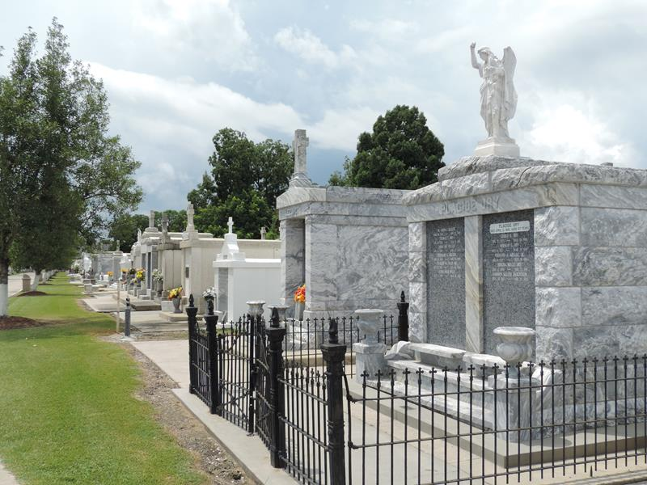

Jessie Joseph Roussel passed away on Thursday, December 11, 2013 at the age of 82. He was a native of Bellmont, La and a resident of Prairieville, La.
He was the beloved husband of Jacqueline Jacob Roussel. He is survived by his children; Joelyn Roussel Perkins (J. Summers), Randy Roussel (Darrelyn Evers), Chris Roussel (Amber Rodrigue), Neil Roussel and Jesse "Jay" Roussel (Stacey Larsen). Grandfather of James Perkins II, Jessica Perkins Clouatre, Jordan Perkins, Randi Elise Roussel, Ryann Paige Roussel, Jason Roussel, Jess Roussel, Rene Roussel, Brooke Roussel, Paige Roussel, Emelie Roussel and Jessie Claire Roussel. Great-grandfather of Max Perkins, Layla Perkins, Jake Perkins and Keller Clouatre. Son of the late John S. and Annette Haydel Roussel. Brother to Eugene Roussel, the late Beaulah Roussel Faucheux , the late John S. Roussel, Jr., the late Daniel Keller Roussel and the late Joseph Pete Roussel.
Jessie was a graduate of Lutcher High School and Loyala University. He went on to coach at Destrehan High School from 1959 to 1980. In 1977 he and his wife opened Roussel's Antiques, with locations throughout the River Parishes.
In lieu of flowers, please make donations to the Coach Jessie Roussel Scholarship Fund, c/o Destrehan High School #1 Wildcat Lane, Destrehan, La 70047.
A special thanks to St. Joseph Hospice and the wonderful caregivers; Emma, Tanya, Sharon and Carolyn.
Relatives and friends are invited to attend a visitation at St. Joseph Catholic Church in Paulina, La on Friday, December 13, 2013 from 10:30am till 1:15pm, a Funeral Mass is to follow at 1:30pm. Interment will take place at St. Peter's Cemetery in Reserve. Condolences may be expressed at www.hcalexanderfh.com

The Times-Picayune, New Orleans, Louisiana
Dec. 12 to Dec. 13, 2013

