Julie (Haydel) Roussel
August 20, 1953 – July 3, 2001

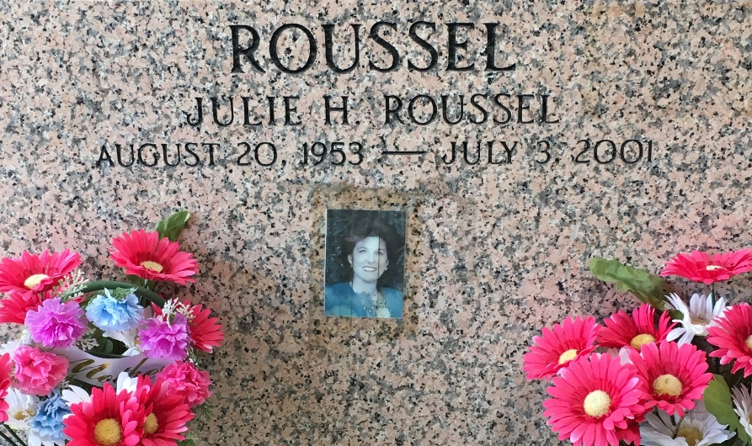
Photo by Team T-Lo

RESERVE - Julie M. Haydel Roussel, 47, a native of Garyville and resident of Reserve for 26 years, died July 3.

She was the wife of Paul M. "Doona" Roussel Jr. and mother of Lori and Hallie Roussel. She was also the daughter of Eva Mae Kliburn Haydel Casey and the late Paul Haydel and sister of Fay Shields, Joy Guidry, Debra Riger, Juliet Templet and Wendy Kliebert. She was an employee of Ondeo NALCO.

Services were July 6 at St. Peter Catholic Church, Reserve, with interment at the church cemetery.
L'Observateur, LaPlace, Louisiana
July 7, 2001

