Laydon J. Roussel
March 21, 1956 – June 4, 2002

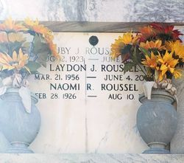
Photo by Team T-Lo

Laydon (Lay-O) Roussel on Tuesday, June 4, 2002 at 9:20 A.M.

Beloved son of Naomi Roussel and the late Ruby Roussel, Sr. Brother of Carla Downhour, Dwight and Ruby Roussel, Jr. Father of Abbie Roussel. Age 46, a native and resident of Reserve, LA.

Relatives and friends of the family are invited to attend the Memorial Services. Visitation at MILLET-GUIDRY FUNERAL HOME, 2806 W. Airline Hwy, Laplace, LA on Thursday, June 6, 2002 from 9:00A.M. - 10:00 A.M. followed by religious services in the funeral home Chapel at 10:00 A.M.

The Times-Picayune, New Orleans, Louisiana
Jun. 5, 2002

