Lois (Austin) Roussel
March 29, 1929 – October 27, 2006

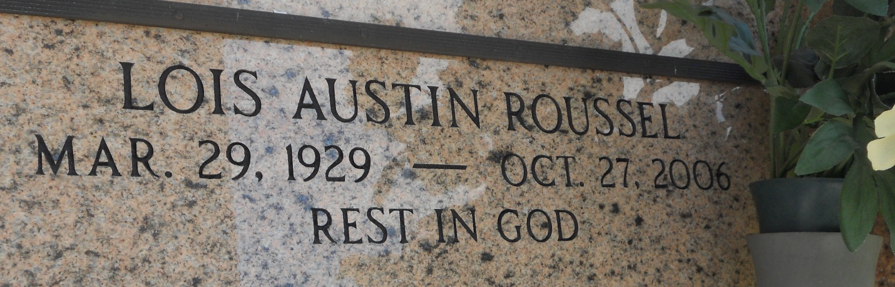
Photo by Team T-Lo

Lois Austin Roussel on Friday, October 27, 2006 at 8:10 p.m.

Beloved wife of the late Walter A. (Red) Roussel, Jr. Daughter of the late Marion Hines and Oneida Englade Austin of Reserve, La. Sister and sister-in-law of Hines Austin and Charlotte Austin of Lafayette La. Aunt of Kay Theunissen of Lafayette, La., Jean Benoit of Natchez, Ms., and Leslie Alderman of Arkansas and many other nieces and nephews. Also survived by devoted sister-in-law Stella Roussel and caregivers Brenda Stockstill, Sheryl Dillard and Helen Billiot.

Age 77 years, a native of Reserve, La. and a resident of Metairie and Montz, La. and Picayune, Ms.

Times Picayune, New Orleans, Louisiana
October 30, 2006

