Mae (Vicknair) Roussel
January 27, 1922 – November 11, 2014

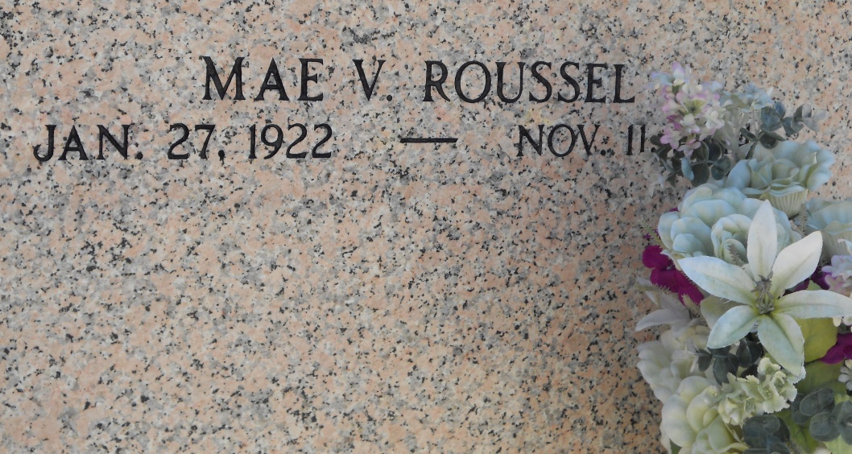
Photo by Team T-Lo

Mae Vicknair Roussel passed away on Tuesday, November 11, 2014 at the age of 92. She was a native and lifelong resident of Reserve, LA.

Beloved wife of the late Anicet "Tom Tom" Roussel. Loving mother of Barry Roussel (wife, Dodie) and the late Charlene R. Stephens (husband, Larry). Daughter of the late Aristide and Gustave Duhe Vicknair. Sister of Agnes Bourgeois, Edgar, Henry and Clinton Vicknair. She is survived by 3 grandchildren and 6 great-grandchildren.

Relatives and friends are invited to attend the Funeral Mass at St. Peter Catholic Church, 1550 Hwy 44, Reserve on Friday, November 14, 2014 at 11:00 a.m. Visitation will begin in church at 9:00 a.m. Interment in St. Peter Cemetery. Arrangements by Millet-Guidry Funeral Home.

The New Orleans Advocate, Louisiana
Nov. 12 to Nov. 14, 2014

