Myrza (Brignac) Roussel
January 3, 1898 – November 14, 1974

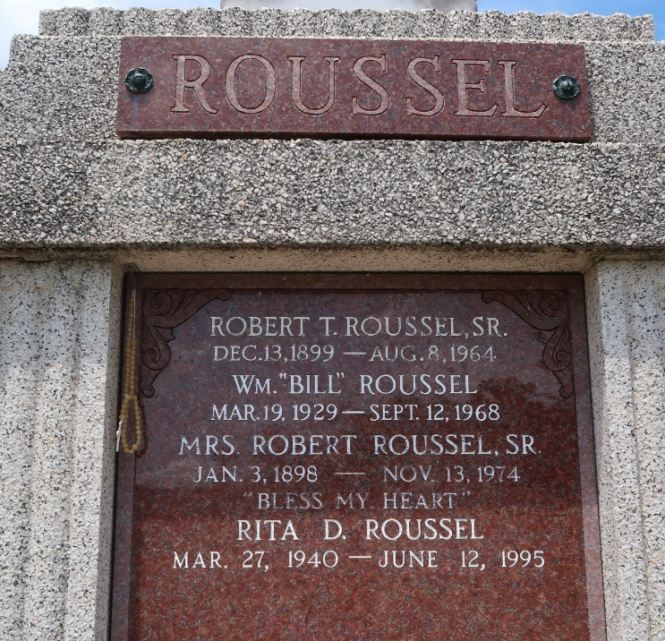

Funeral services for Myrza Roussel of Reserve were held Nov. 15 at St. Peter Catholic Church, Reserve. Interment in the church cemetery.
Mrs. Roussel, the former Myrza Brignac, died Nov. 13 at the age of 76. A native of Gramercy, she had been a resident of Reserve for the past 45 years.
Her husband, Robert Roussel Sr., preceded her in death. Survivors include four sons, Robert Jr., Paul, Terry and Brent Rousse, all of Reserve; five daughters, Esther Heltz, Marie Klibert, Marion Entremont and Myrza “Nookie” Ruiz, all of Reserve, and Emma Laiche of Luling; and three brothers, Norman Brignac Sr., Lutcher, Albert Brignac Sr., Reserve, and Ursin Brignac of Norco; 30 grandchildren; eight great-grandchildren.

L’Observateur, LaPlace, Louisiana
November 21, 1974, p. 4

