Naomi (Remondet) Roussel
February 28, 1926 – August 10, 2013

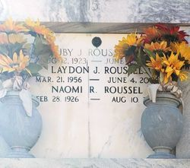
Photo by Team T-Lo

U.S., Obituary Collection, 1930-2016

Name Naomi Remondet Roussel
Gender Female
Death Age 87
Birth Date abt 1926
Residence Place Reserve, LA.
Death Date 10 Aug 2013
Obituary Date 11 Aug 2013
Parents Dennis Remondet; Ida Remondet
Spouse Ruby Roussel
Child Carla Downhour; Ruby Roussel; Dwight Roussel
Siblings Beatrice Hymel; Eloi Remondet; Oledia Poche; Lorina Poche; Eugene Remondet; Aurelia Remondet; Cleven Remondet
**

Naomi Remondet from tree Cambre - Raymond Brignac Family Tree

Birth 28 Feb 1926 Louisiana, USA
Residence 2002 Reserve, St John the Baptist, Louisiana, USA
Death 10 Aug 2013
Father Dennis Joseph Remondet (1889-1957)
Mother Ida Kliebert (1896-1982)
Spouse Ruby Joseph Roussel (1928-2010)
29619 People 5 Records 6 Sources

