Neil Thomas Roussel
December 2, 1961 – January 9, 2024

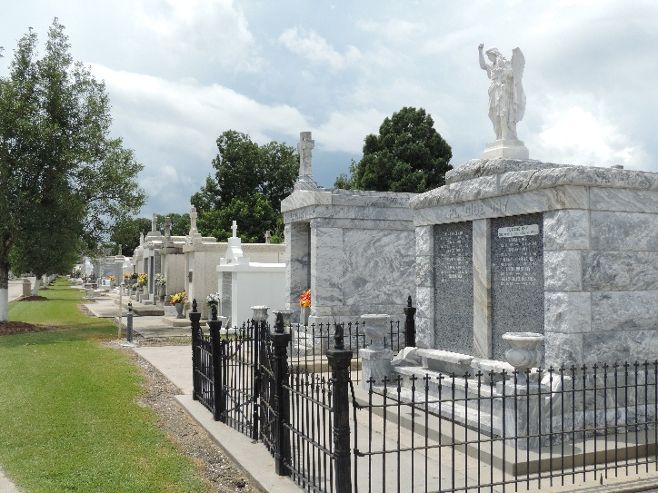

Neil Thomas Roussel passed away on Tuesday, January 9, 2024. Neil is survived by his daughters: Brooke Roussel and Paige Roussel, who he loved very much, his girlfriend, Judy Albarado, who took care of him faithfully in his final days, and his four siblings: Joelyn Roussel Perkins (Summers), Randy Roussel (Darrelyn), Chris Roussel (Amber), and Jay Roussel (Stacey).
Neil was born in New Orleans, lived in Norco, LaPlace, Ponchatoula, and Slaughter, LA. Neil is a 1980 graduate of Destrehan High School. From the younger years of his life, Neil's soul resonated with the beauty of antiques and wood craftsmanship, a passion that bloomed into the creation of Roussel’s Antiques of LaPlace alongside his late parents, Jessie and Jackie Roussel (who preceded him in death). He was a collector of glass bottles, antique furniture and architectural pieces, and collectibles. This familial endeavor flourished, nurturing not just a business, but a tapestry of shared moments and memories across five currently operating stores.
A Graveside Service will be held at St. Peter’s Catholic Cemetery, 1550 Hwy 44, Reserve, LA on Friday, January 19th, 2024 at 2 PM. A reception will follow the service at Bot’s, 2810 W. Airline Hwy, LaPlace (in the old “barn building” where Neil used to work with his mom and dad). Friends and Family are invited to come and share their memories of Neil.
In lieu of flowers, please make donations to the Coach Jessie Roussel Scholarship Fund, c/o Destrehan High School #1 Wildcat Lane, Destrehan, La 70047.

Rose Lynn Funeral Home, Lutcher, Louisiana
January 15, 2024

