Nelson Joseph Roussel
October 9, 1917 – August 25, 2004

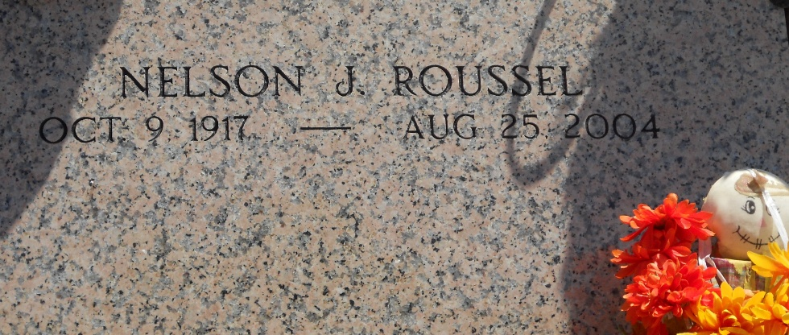
Photo by Team T-Lo

Nelson J. Roussel on Wednesday, August 25, 2004 at 8:01 PM.

Beloved husband of the late Lucrece G. Roussel. Father of Kathleen R. (Cat) Powell of LaPlace, David L. Roussel of Destrehan and Jeanne R. Regan of Montgomery, AL. Son of the late Emile and Olivia Roussel. Brother of Bessie Carnaggio, Lydia Millet, Marian Levy and also the late Paul, Hubert and Lee Roussel, Inez Luquette, Marguerite Aucoin and Lizette McCann. Beloved grandfather of Zachary, Amber and Lucas Roussel and Glenn and Jessica Regan. Age 86. A native of Paulina, LA. and a resident of Norco, LA. for the past 50 years.

Relatives and friends of the family are invited to attend services. Visitation at Millet-Guidry Funeral Home, 2806 West Airline Hwy, LaPlace on Saturday, August 28, 2004 from 8:30 AM to 10:00 AM. Followed by Religious Services in the funeral home chapel at 10:00 AM. Burial in St. Peter Cemetery, Reserve.

The Times-Picayune, New Orleans, Louisiana
Aug. 27, 2004

