Randy Paul Roussel
April 15, 1963 – June 20, 2009

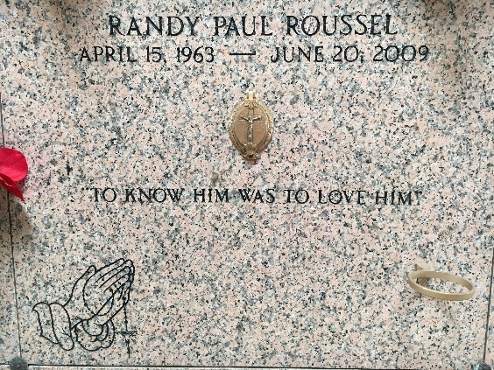
Photo by Team T-Lo

Randy Paul Roussel entered eternal rest on Saturday, June 20, 2009, at his home in Decatur, Alabama surrounded by his loving family.
Randy was born on April 15, 1963, to Joy Ann Matherne and H.E. ("Poochie") Roussel, Jr. A former resident of Norco, Louisiana, Randy received his Chemical Engineering degree from LSU, and was an avid Tiger and Saints fan. He worked for Daikin America, Inc. for the last 17 years, in positions such as a regulatory affairs manager and most recently as a project engineering manager.
Randy is preceded in death by his father, H. E. ("Poochie") Roussel, Jr., his maternal grandparents, Randolph and Mildred Matherne and his paternal grandfather, H.E. ("Cadie") Roussel, Sr.
He is survived by his devoted mother, Joy Ann Matherne Roussel; his brothers Kevin Roussel and wife Kerri Montz Roussel, and Craig Roussel and wife Yvette Tavan Roussel; and his paternal grandmother, Noelie Roussel. He is the proud uncle of Connor and Cameron Roussel and Matthew and Jessica Roussel. He was the godfather of Chad Becnel and Cameron Roussel. Randy is also survived by his longtime loving friend, Eriko Ellis; as well as his aunts, uncles and many cousins. A heartfelt thanks to his godmother, Nannie GayNell Becnel, for her loving and gentle hands.
The Roussel family would like to express their deepest gratitude to Randy's many doctors, nurses, Hospice of the Valley, and his many wonderful and gracious friends and co-workers.
Relatives and friends are invited to a visitation on Tuesday, June 23, 2009, from 5:00 p.m. until 9:00 p.m. at H.C. Alexander Funeral Home, 821 4th Street, in Norco, Louisiana. A morning visitation will be held on Wednesday, June 24, 2009, beginning at 8:00 a.m. at the funeral home, with a Funeral Mass to be held at 11:00 a.m. at Sacred Heart of Jesus Catholic Church, 401 Spruce Street, in Norco. Interment will follow at St. Peter Cemetery in Reserve. A Memorial Mass will be held in Decatur, Alabama at a later date. In lieu of flowers, memorials may be made to a cancer organization of your choice. Funeral arrangements are under the direction of H. C. Alexander Funeral Home in Norco.

The Times-Picayune, New Orleans, Louisiana
June 23-24, 2009

