Kierston Pierre ‘Iggy’ Roussell
April 23, 1985 – April 9, 2018

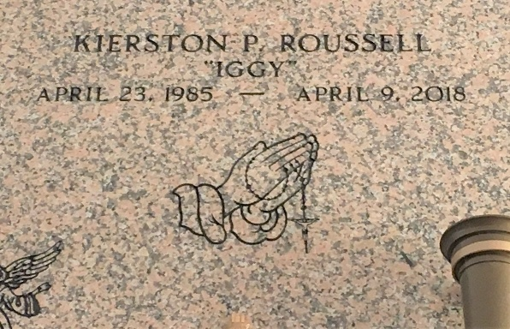
Photo by Team T-Lo

Kierston Pierre Roussell, son of Junius Roussell III and Lisa S. Roussell, came into this world on April 23rd of 1985, a lifelong resident of LaPlace, La. He was raised in a God-fearing and loving household. He was Christened at this very church. Afterwards, having his own personal relationship with the Lord, Kierston decided at Powerhouse Christian Church to be baptized and do the Lord's work.
He had many talents and many things he liked to do. He loved drawing, he played football at East St. John High School and he loved to make beats and music in spare time. He was a chef in his own mind and quite a few people agreed to that. He also was a world-wide gamer and enjoyed competing online with his friends. Most of all, Kierston loved making people laugh and feel good. He had a way of leaving a special mark on everyone he would meet. His personality will forever be unforgettable.
He did what the good Lord wanted him to do, which is spread Faith, Hope and most of all Love, for even in the end these are the three things that remain. No matter how much time passes, Kierston will remain in the hearts of all those he leaves behind with his memories; Memories that have passed and memories that will be around for years to come. Kierston leaves behind his legacy to be carried out by his father, Junius Roussell III; his mother: Lisa S. Johnson (Samuel Johnson); siblings: Audriana and Meosha Roussell; his grandmother: Abbie Mae Roussell; the love of his life and wife-to-be: JePrece Barrit; their beautiful kids: Jermall William, Asia Nicole and Skylar Christopher Roussell; Future father and mother in law: Richard and Kristin Magee; His brother in laws-to-be: Richard Barritt and Andre Barrit; his new family mother in love: Susan Medina; Siblings-in-love: Christina and Luis Medina. He also leaves behind a host of aunts, uncles, cousins, family, co-workers, loved ones and friends.
He went home to meet the Lord on April 9, 2018 to hear the words that everyone one day hopes to hear: "Well done, my good and faithful servant". There to be greeted by his grandparents: Junius Roussell Jr., Pierre Scott and Audrey Goudia-Scott; his uncles: Errol Gene "Geno" Edwards, Stacey and Dale Scott and other late loved ones. According to God's promise, we all trust that this is not goodbye, but yet farewell until the day that we meet again! Farewell Services are private. Bardell's Mortuary of Mt. Airy, La. in charge.

The New Orleans Advocate, Louisiana
Apr. 12 to Apr. 14, 2018

