Roland Roussell Sr.
February 24, 1937 – December 24, 2006

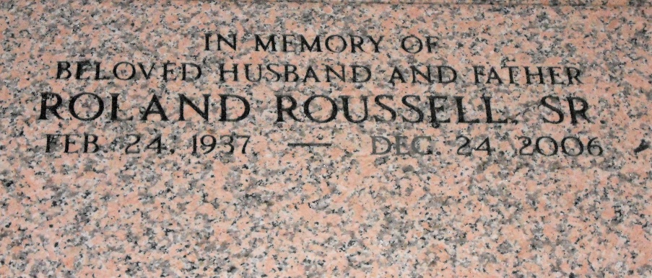
Photo by Team T-Lo

Roland Roussell, Sr. departed this earthly life and entered into rest on Sunday, December 24, 2006 at his residence in Mt. Airy, La.
Beloved husband of Mary Roussell of Mt. Airy, La. Loving father of Roland Roussell, Jr. of Vacherie, La., Zenobia Gray of Laplace, La., Monique McDonald of Jackson, Ms., Pamela Roussell, Shantrese Roussell and Jason Roussell, all of Mt. Airy, La.
Son of the late Mazie Roussell and Junius Roussell, Sr. Stepson of Wilma Edward of Mt. Airy, La. Brother of Marie Joseph, Junius Roussell, Jr., John Roussell, Zenobia Taylor, Eugene Roussell and the late Veronica Joseph and Georgia Ann Rixner. Also survived by 11 grandchildren, nieces, nephews, other relatives and friends.
Times Picayune, New Orleans, Louisiana
December 27, 2006

