Herbert Howard Royal Sr.
October 24, 1927 – January 19, 2006

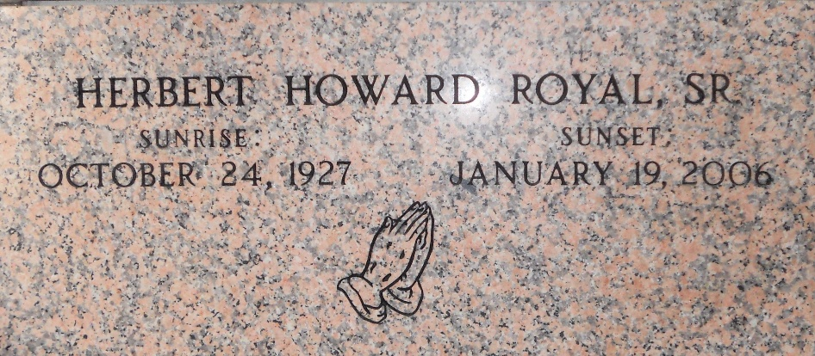
Photo by Team T-Lo

Herbert (Ta-Belly) H. Royal, Sr. on Thursday, January 19, 2006 at River Region Hospice House, River Ridge, LA.
Son of the late Mary Rollins and Alexander Royal. Husband of the late Leona Etienne Royal. Father of Herbert (Patricia) Royal, Jr., Kevin Royal, Mary R. Watkins, Patricia (Kenneth) R. Smith, Monica (Bruce) R. Ingram and Jonas Royal. Brother of the late Cecile Roberts, Rachel Johnson, Alexander and Christopher Royal. Brother-in-law of Mable Ceaser, Sadie Tillery and Albertine Etienne. Also survived by 7 grandchildren and a host of nieces, nephews, other relatives and friends. Age 78 years. A native of St. Rose, LA. and a resident of Montz, LA.
Relatives and friends of the family, also priest and parishioners of Our Lady of Grace Catholic Church and all neighboring churches and employees of Atmos Energy, Twin Oaks Nursing Home, Children Hospital, River Parishes Hospital and Harry Hurst Middle School are invited to attend the Mass of Christian Burial at Our Lady of Grace Catholic Church, 772 Highway 44 (River Road), Reserve, LA. on Saturday, January 28, 2006 at 11:00 AM. Father Joseph Rodney, Celebrant. Interment St. Peter Cemetery, Reserve, LA. Visitation at the above named church from 9:00 AM until Mass time. SERVICED BY ROBOTTOM
Times Picayune, New Orleans, Louisiana
January 27, 2006

