Elmo Armand Ruiz
August 31, 1905 – April 2, 2001

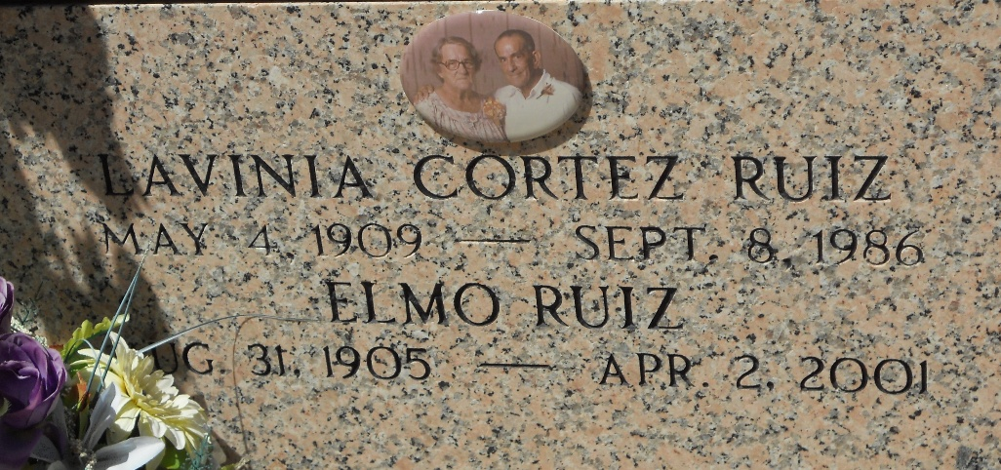
Photo by Team T-Lo

RESERVE - Elmo "La Sauce" Armand Ruiz, 95, a native of Barton and resident of Reserve for 82 years, died April 2.

He was the husband of the late Lavinia Cortez Ruiz and father of Rosemary Deslatte, Fay Richard, Junior Ruiz and the late Clarence "Hickey" Ruiz. He was also the son of the late Frank and Angelina Ruiz and brother of Bertha Duhon. He is also survived by 11 grandchildren, 20 great-grandchildren and one great-great-grandchild. He was preceded in death by one grandchild.

Services are today at 10:30 a.m. at St. Peter Catholic Church, Reserve, with interment at the church cemetery. Visitation starts at 8 a.m. In lieu of flowers, donations preferred to the American Cancer Society.
L'Observateur, LaPlace, Louisiana
April 4, 2001

