Louise ‘Loe’ (Catoire) Ruiz
April 9, 1932 – November 26, 2022

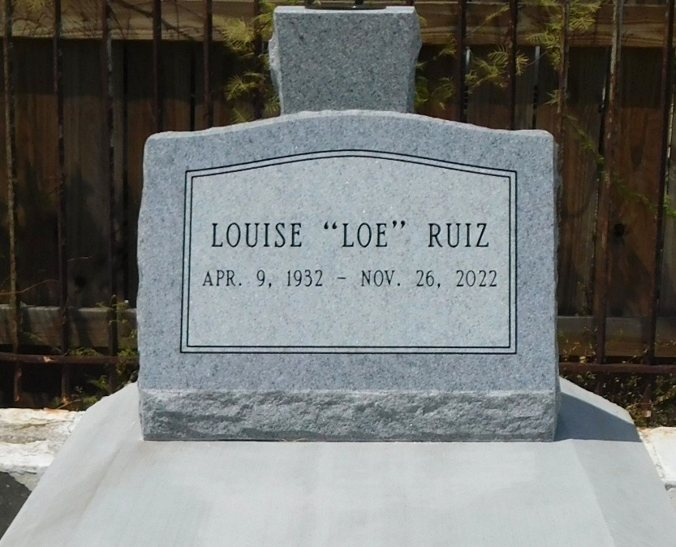
Photo by Mary Agnes Hammett

Louise C. Ruiz passed away on Saturday, November 26, 2022 at the age of 90. She was born in Reserve, LA and a resident of LaPlace, LA.
Beloved wife of Lawrence J. Ruiz. Loving mother of Susie LaPorte, Lynn Ruiz and the late Kerry Ruiz and Matt Ruiz. Daughter of the late Catherine Cambre Catoire and Henry Paul Catoire, Sr. Also survived by 8 grandchildren and 7 great grandchildren.
Relatives and friends are invited to attend the Visitation and Funeral Service at Millet-Guidry Funeral Home, 2806 W. Airline Hwy., LaPlace on Thursday, December 1, 2022. Visitation from 9:00 a.m. to 11:00 a.m. followed by a Funeral Service at 11:00 a.m. Interment in St. Peter Cemetery, Reserve, LA.

Millet-Guidry Funeral Home, LaPlace, Louisiana
November 28, 2022

