Myrza (Roussel) Ruiz
March 22, 1936 – December 16, 2024

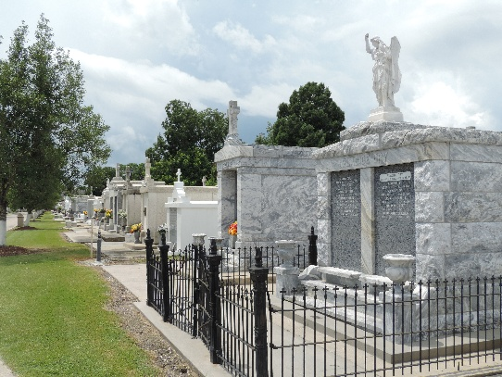

Myrza Roussel "Nookie" Ruiz passed away peacefully on Monday, Decem-ber 16, 2024, at the age of 88. She was a native and longtime resident of Reserve, LA and most recently of Amite, LA.
She was preceded in death by her husband, Clarence "Hickey" Ruiz; parents, Robert and Myrza Brignac Roussel; siblings, Norris Roussel, Esther Heltz, Robert "Bob" Roussel, Jr., Ruby Roussel, Sr., Emma Laiche, Marie Kleibert, Russell Roussel, William "Bill" Roussel, Paul Roussel, Marian Entremont, Terry Roussel and Brent Roussel. She was a loving wife, mother and grandmother.
Myrza is survived by her children, Trudy Giardina (Angelo) and Todd Ruiz (Toni). She is also survived by her grandchildren, Lauren Cutrer (Drew), Jared Shows (Mahsa), Taylor David (Layne), Madeline Fisher (Adam), and Hilary Bonano (Mason); great grandchildren, Ava Cutrer, Aidan Shows, Rhett and Amelia David, and Ayden and Easton Fisher. Also survived by numerous nieces and nephews.
The family would like to thank the staff at The Lodge at Tangi Pines and Modern Hospice for their loving care.
Relatives and friends are invited to attend the Visitation and Funeral Mass at St. Peter Catholic Church,1550 Hwy 44, Reserve, LA, on Saturday, December 21, 2024. Visitation at the church from 9:00 a.m. to 11:00 a.m. followed by a Funeral Mass at 11:00 a.m. Interment in St. Peter Catholic Cemetery, Reserve, LA. Arrangements by Millet-Guidry Funeral Home.

Millet-Guidry Funeral Home, LaPlace, Louisiana
December 17, 2024

