Clementine (Madere) Rushing
May 13, 1894 – February 25, 1975

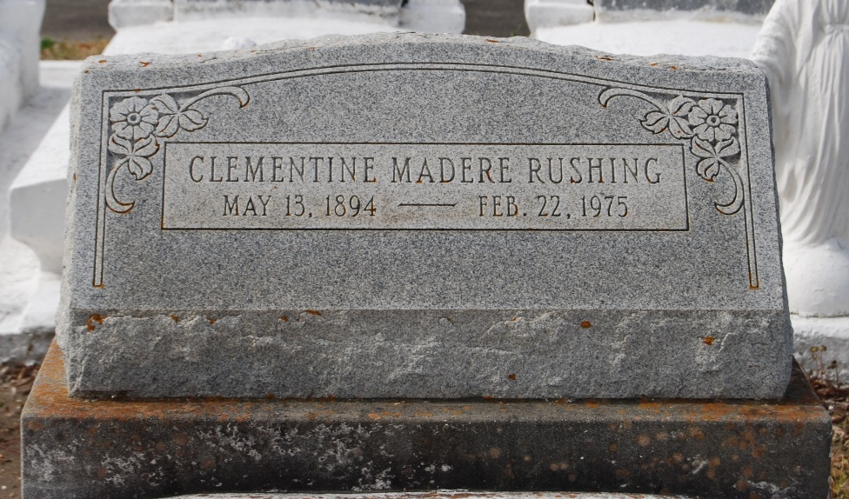
Photo by Kerry Keller

Clementine Madere Rushing, a native of Laplace, Louisiana, and a resident of Metairie, Louisiana, for the past 15 years, died Saturday 22 Feb 1975 at 4:00 p.m. at age 80 years.

She was the mother of Willie Mae Barrois of Good Hope, Louisiana, Mrs. Warren (Beverly) Ales of Metairie, and the late C. J. Rushing.

Services were Monday, 24 Feb. 1975 at St Joan of Arc Church, Laplace, with interment in St Peter Cemetery, Reserve, Louisiana.
The Times-Picayune, New Orleans, Louisiana
24 Feb 1975

