Gene Paul Ryan Sr.
November 16, 1939 – February 3/2026

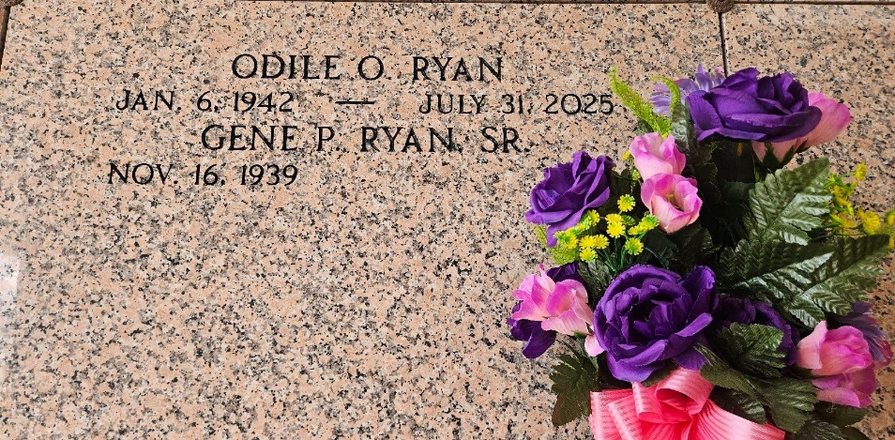
Photo by Team T-Lo

Gene P. Ryan, Sr., a resident of Garyville, LA, passed away on Tuesday, February 3, 2026, at the age of 86.
He was the beloved husband of the late Odile Ryan and the father of Gig Landry (the late Joey), Gene Ryan, Jr. (Amy), and Craig Ryan. He is also survived by his grandchildren Ryan Landry, Whitney Anderson (Will), Courtney Bramley (Kyle), Anne-Marie Johnston (Casey), Benjamin Ryan, and Brandon Ryan as well as great-grandchildren Xander, Zoe, Joseph, Anna, Caroline, Dominic, and Ellie.
Gene was preceded in death by his mother, Ella Alexander Ryan, and his brother, Alan Ryan, Sr. (Dolly). He is survived by additional family members, including many nieces, nephews, and cousins.
The family would like to extend their heartfelt gratitude to Kevin Duhon and Troy Murray for the care and support they provided during Gene’s final days.
Relatives and friends are invited to attend the visitation and Funeral Mass on Saturday, February 7, 2026, at St. Hubert Catholic Church. Visitation will be held from 9:00 a.m. to 11:00 a.m., followed by a Mass of Christian Burial at 11:00 a.m. Burial will follow at St. Peter Cemetery in Reserve.

Rose Lynn Funeral Home, Lutcher, Louisiana

