Odile (Oubre) Ryan
January 6, 1942 - July 31, 2025

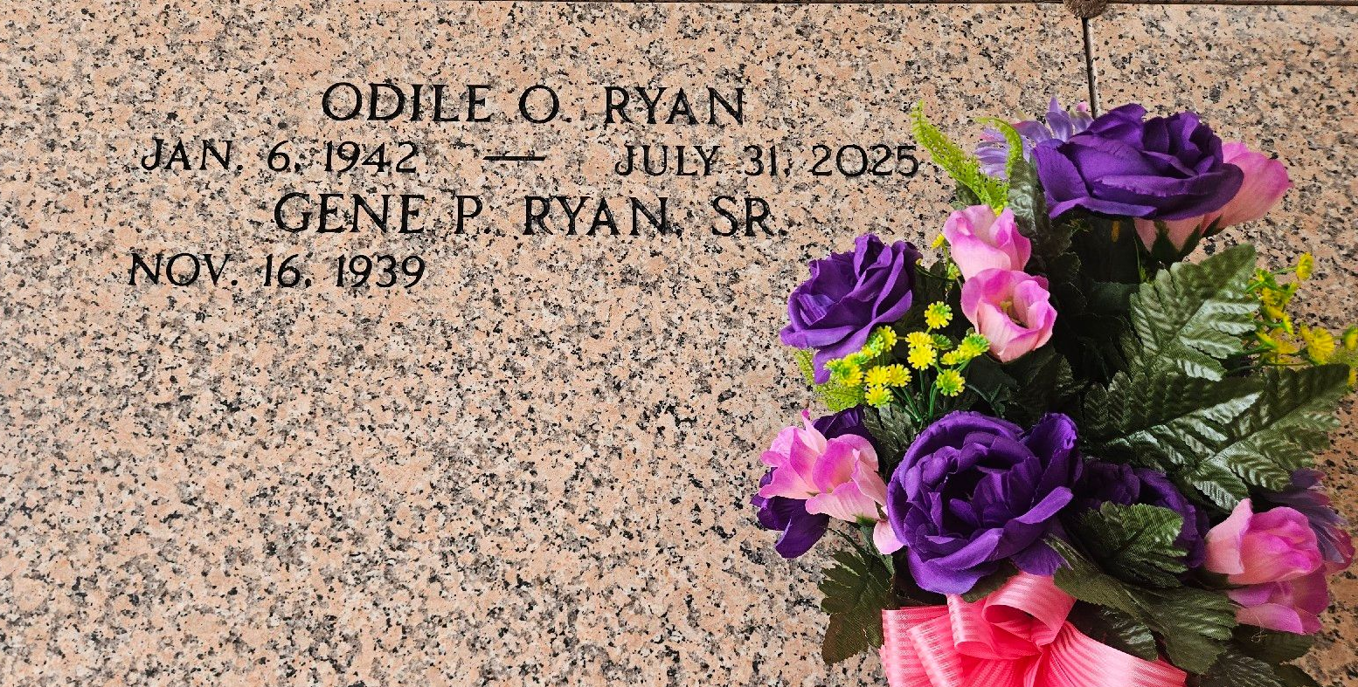
Photo by Team T-Lo

Odile Oubre Ryan a resident of Garyville, LA passed away on Thursday, July 31, 2025 at the age of 83.
Beloved wife of Gene Ryan, Sr. Loving mother of Gig Landry (the late Joey), Gene Ryan, Jr (Amy), Craig Ryan. Grandmother of Brandon Ryan, Ryan Landry, Whitney Anderson (Will), Courtney Bramley (Kyle), Anne-Marie Johnston (Casey), Benjamin Ryan. Great-grandmother of 6.
Daughter of the late Hubert Oubre, Sr. and Clara Navarra Oubre. Sister of Clair Zeringue, Penny Vicknair (the late Robert “Bob”), Anna Webre (the late Farrel, Sr), Hubert Oubre, Jr (Chris), Johnny Oubre (Connie), Danny Oubre (Faye), Andrea Matherne (the late Johnny), Sharon Stewart (Gordon), and the late Coleman Oubre (Shelia). Also survived by numerous nieces, nephews and cousins.
Odile was very active in St. Hubert Parish and a proud member of the Catholic Daughters of America and the St. Hubert Altar Society. She loved her grandchildren and her great-grandchildren more than anything.
Relatives and friends are invited to attend the Visitation and Funeral Mass on Monday, August 4, 2025 at St. Hubert Catholic Church. Visitation will be from 9:00 am - 11:00 am with the Funeral Mass starting at 11:00 am. Burial will follow the service at St. Peter Catholic Cemetery.

Rose Lynn Funeral Home, Lutcher, Louisiana
August 3, 2025

