Emma A. (Madere) Salisbury
August 26, 1914 – January 7, 1985

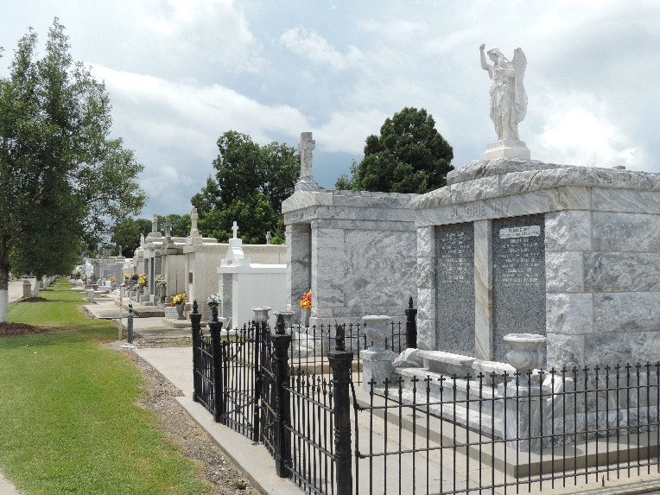

SALISBURY

Emma Boudreaux Salisbury on Monday, January 7, 1985 at 12:15 p.m.. Beloved wife of Robert Salisbury, mother of Lucien Boudreaux, Mrs. Elizabeth Landry, Mrs. Joycalyn Coniglio, Gary Boudreaux, David Boudreaux, Dawn Boudreaux, all of Laplace, LA. and Neil Boudreaux of Norco, LA. Sister of Grace Wallace and Jennie Bridgeman, also survived by 19 grandchildren and 5 great-grandchildren. Age 70, a native of Hahnville, LA, and a resident of Norco, LA for the past 50 years.
Relatives and friends of the family are invited to attend the funeral services from the H. C. Alexander Funeral Home, 821 Fourth St., Norco, LA on Wednesday, January 9, 1985 at 2:00 o’clock p.m. Mass of Christian Burial at Sacred Heart of Jesus Catholic Church, Norco, LA. Interment St. Peters Mausoleum, Reserve, La. Friends may call on Tuesday, January 8, 1985 from 6:00 until 10:00 p.m. and from 8:00 a.m. until service time on Wednesday.

Unknown newspaper clipping

