Mamie (Gilardi) Salvaggio
February 20, 1886 – July 25, 1957

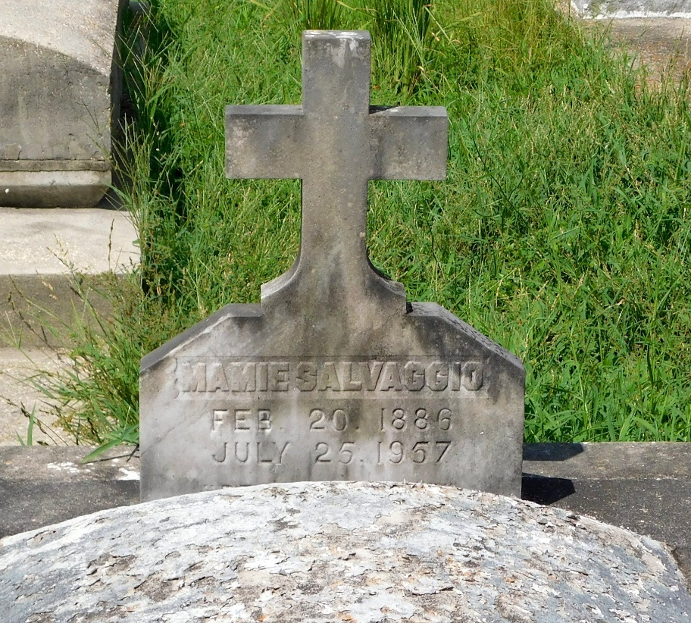
Photo by Mary Agnes Hammett

SALVAGGIO

At Our Lady of the Lake Hospital, Baton Rouge, La, on Thursday, July 25, 1957, at 7 o'clock p.m., MAMIE SALVAGGIO, wife of Salvadore Salvaggio; mother of Anthony of Baton Rouge, La, Sam, Raymond and Bazile Salvaggio of New Orleans, La, Joseph Salvaggio of Washington, DC, Jasper Salvaggio of Hermosa Beach, Calif, and Mary Salvaggio of Baton Rouge, La; sister of Mrs. Frances Saleva of Chicago, Ill; survived by 12 grandchildren and several nieces and nephews.
Relatives and friends of the family are invited to attend the funeral from the Rabenhorst funeral parlors, 825 Government St, Baton Rouge, La, on Saturday morning, July 27, 1957. Interment St Peter cemetery, Reserve, La.
The Times-Picayune, New Orleans, Louisiana
26 Jul 1957, p. 2

