Salvador Salvaggio
May 3, 1886 – May 12, 1968

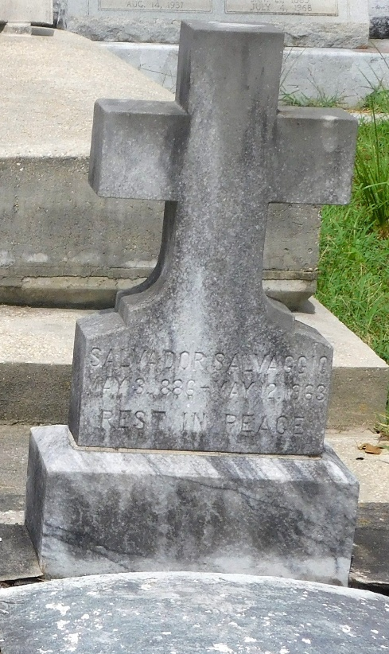
Photo by Mary Agnes Hammett

SALVAGGIO

Of 2007 N 15th st, Baton Rouge, La, on Sunday, May 12, 1963, at 7:15 o'clock a.m., SALVADOR SALVAGGIO, father of Sam Jr, Raymond and Basile Salvaggio of New Orleans, Anthony Salvaggio of Baton Rouge, Joseph Salvaggio of Gulfport, Miss, Gasper Salvaggio of Coco Beach, Fla, and Miss Mary Salvaggio of Baton Rouge; brother of Michael and Rose Salvaggio of New Orleans, survived by 16 grandchildren and 2 great grandchildren, age 77 years, a native of Italy and a resident of Baton Rouge for 8 years.
Relatives and friends of the family, also members of the New Orleans Vehicle Dept. Inspection Station and members of American Legion Post No 273, are invited to attend the funeral. Services from The Hollabaugh-Spindle Funeral Home, 2929 Scenic Highway, Baton Rouge, La, on Monday, May 13, 1963, at 10:30 o'clock a.m., religious services at St Anthony Catholic Church. Interment St Peter Cemetery, Reserve, La.
The Times-Picayune, New Orleans, Louisiana
13 May 1963, p. 2

