Alfred J. Sanchez
February 27, 1872 – December 4, 1909

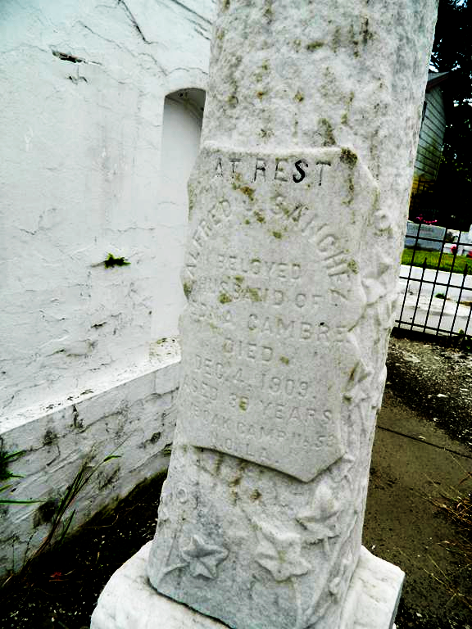

SANCHEZ - At his residence, No. 1448 Magazine Street, on Saturday, Dec 4, 1909, at _ o'clock p.m, ALFRED J SANCHEZ, husband of Edna Cambre, aged 37 years 10 months,_ native of St James Parish, and a resident o_ this city for many years.
Friends and acquaintances of the family also officers and members of Pelican Lodge No. 121, B.K. of A.; Reserve Lodg_ B._ of A., and Live Oak Camp No. 53, W.O.W. are invited to attend the funeral services a_ St Peter's Church on arrival of Y. & M. _ train, Monday morning, Dec 6 Dec, at Reserve, La.
The Daily Picayune, New Orleans, Louisiana
5 Dec 1909, p 9

