Bobbie (Adams) Satterlee
July 17, 1956 - June 14, 2025

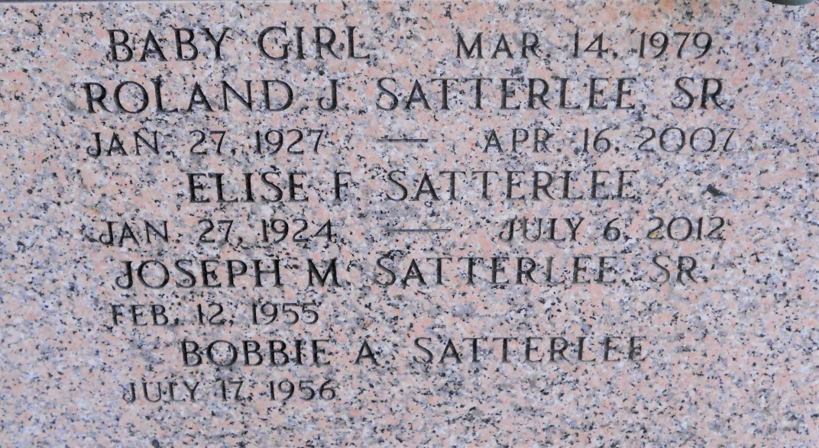
Photo by Team T-Lo

Bobbie Adams Satterlee passed away at her home surrounded by her family on Saturday, June 14 2025 at the age of 68. She was born in Tuscaloosa, AL and was a resident of LaPlace, LA.
Beloved wife of 50 years to Joseph Satterlee, Sr. Loving mother of Joseph Satterlee, Jr. (Lindsey). Grandmother of Kale, Asher and Sophie. Daughter of the late James Henry Adams and Betty Jo Elliott Davis. Sister of Patricia (Richard), Deborah (Charlie), Barbara (Danny), Tammy (Paul), Cheryl, Mike and John. Also survived by a host of nieces and nephews.
Relatives and friends are invited to attend the Funeral Service. Visitation will be held at Millet-Guidry Funeral Home, 2806 W. Airline Hwy., LaPlace on Friday, June 20, 2025 from 6:00 p.m. to 10:00 p.m. and on Saturday, June 21, 2025 the visitation will be held at St. Joan of Arc Catholic Church, 595 W. 5th St., LaPlace from 9:30 a.m. to 11:00 a.m. A catholic prayer service will immediately follow at 11:00 a.m. Interment in St. Peter Cemetery.

Millet-Guidry Funeral Home, LaPlace, Louisiana

