Elise Frances (Fertitta) Satterlee
January 24, 1924 – July 6, 2012

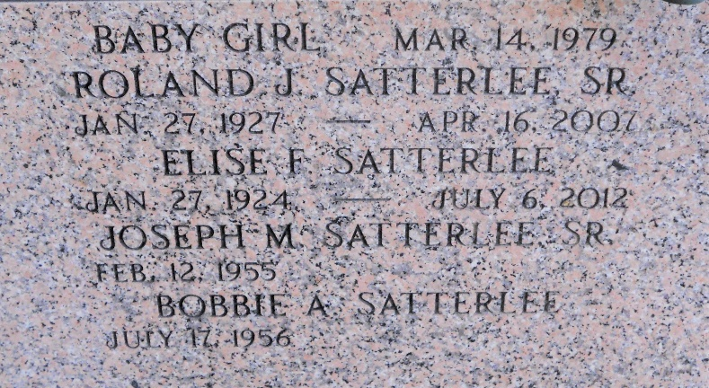
Photo by Team T-Lo

Elise Fertitta Satterlee passed away on Friday, July 6, 2012 after a long battle with Alzheimers.
Beloved wife of the late Roland (Chut) Satterlee. Mother of Joe Satterlee Sr. (Bobbie), Russell Satterlee (Connie) and the late Roland Satterlee Jr. Grandmother of Anthony, Joseph, Garett and Evan Satterlee, Sherry Mince, Kristy Ibarra and Tiffany Landry. Great-grandmother of Logan and Gabriele Mince, Lance and Lilianna Ibarra, Sebastian Landry, Garett Jr., Kale and Braedon Satterlee.
Daughter of the late Joseph and Marie Fertitta. Sister of the late Annie Zeringue, Shirley Steele, Sarah Browning and Lucy McClure. Age 88. A native of Kenner, LA and a resident of LaPlace, LA for the last 7 years.
Relatives and friends of the family are invited to attend services. Visitation at Millet-Guidry Funeral Home, 2806 W. Airline Hwy., LaPlace, LA on Monday July 9, 2012 from 5:00pm to 9:00pm and on Tuesday at St. Joan of Arc Catholic Church, 529 W. 5th St., LaPlace, LA from 8:00am to 10:00am followed by Mass at 10:00 am. Burial in St. Peter Cemetery, Reserve, LA.

The Times-Picayune, New Orleans, Louisiana
July 7-8, 2012

