Helen (Clement) Satterlee
November 13, 1929 – February 27, 2009

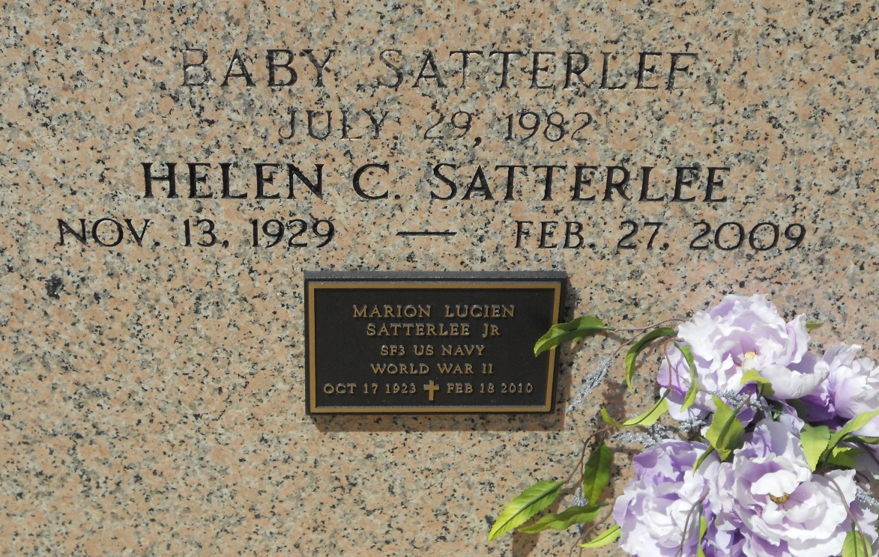
Photo by Team T-Lo

Helen Clement Satterlee on Friday, February 27, 2009 at 5:15.p.m. Beloved wife of Marion Satterlee. Mother of Linda Myers and husband Lew and Richard Satterlee. Grandmother of Amy and Dustin Satterlee and 3 step-grandchildren.
Daughter of the late William and Aline Clement. Sister of Juliette Alford, Lilly Starkes, Melba Catoire, Carmen Weber, Elizabeth Cehlar, Jerry Clement and the late Daniel, William Jr. and Roy Clement and Nina Scalco. Age 79. Native and resident of LaPlace, La.
Relatives and friends are invited to attend services. Visitation at Millet-Guidry Funeral Home, 2806 W. Airline Hwy., LaPlace, La. on Sunday, March 1, 2009 from 5:00 p.m. to 9:00 p.m. and on Monday from 8:00 a.m. to 10:00 a.m. Followed by Religious Services at the Funeral Home Chapel at 10:00 a.m. Burial in St. Peter Cemetery, Reserve, La.

The Times-Picayune, New Orleans, Louisiana
April 18, 2007

