Marion Lucien Satterlee Jr.
October 17, 1923 – February 19, 2010

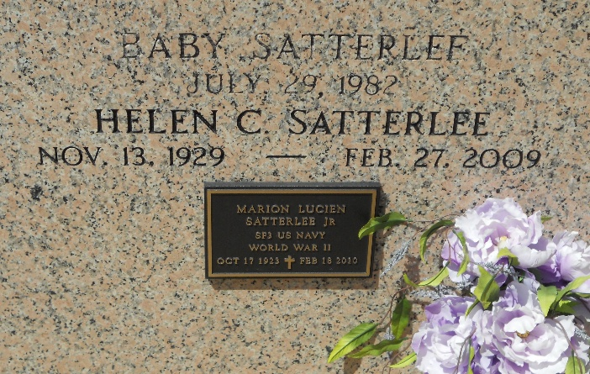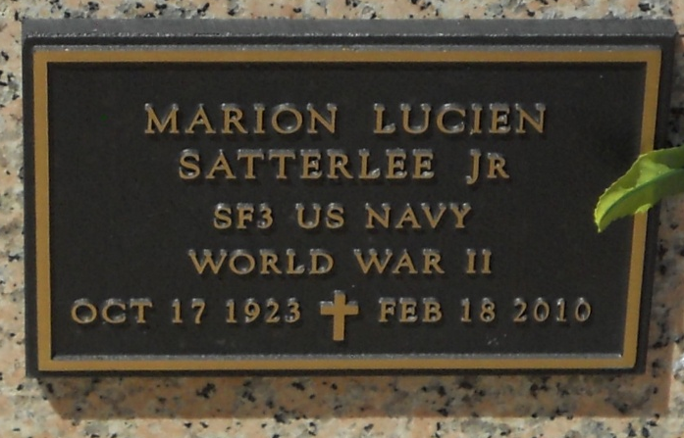
Photo by Team T-Lo

Marion Satterlee, Jr. passed away on Thursday, February 18, 2010. Beloved husband of the late Helen Clement Satterlee. Father of Linda Myers and husband Lew and Richard Satterlee. Grandfather of Amy and Dustin Satterlee and 3 step-grandchildren. Son of the late Marion and Blanche Delhommer Satterlee. Brother of Ruth Schexnayder and the late Roland (Chut) and Herbert Satterlee. Age 86 years. A native and resident of LaPlace.

Relatives and friends are invited to attend services. Visitation at Millet-Guidry Funeral Home, 2806 W. Airline Hwy., LaPlace, LA, on Friday, February 19, 2010 from 5:00 PM until 8:00 PM and on Saturday from 8:00 AM until 11:00 AM. Followed by a Religious Service at the Funeral Home Chapel at 11:00 AM. Burial in St. Peter Cemetery, Reserve.

The Times-Picayune, New Orleans, Louisiana
February 19, 2010

