Roland J. Satterlee Sr.
January 27, 1927 – April 16, 2007

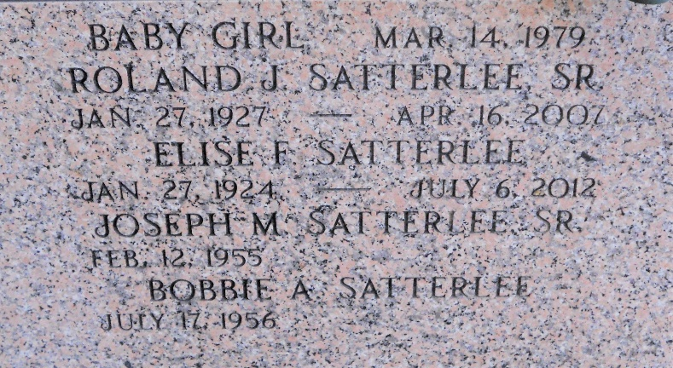
Photo by Team T-Lo

Roland J. (Chut) Satterlee, Sr. on Monday, April 16, 2007 at 7:53 a.m. Beloved husband of Elise Fertitta Satterlee for 55 years. Father and father-in-law of Joe Sr. and Bobbie Satterlee, Russell and Connie Satterlee and the late Roland J. Satterlee, Jr. Grandchildren and spouses: Anthony Satterlee, Sherry and Skip Mince, Kristy and Jorge Ibarra, Tiffany and Clint Landry, Joseph Jr and Krista Satterlee, Garett Sr. and Deidra Satterlee and Evan Satterlee. Great-grandchidlren: Logan and Gabriele Mince, Lance and Lilianna Ibarra, Garett Satterlee, Jr. and Sebastian Landry. Son of the late Marion Sr. and Blanche Delhommer Satterlee. Brother and brother-in-law of Marion Jr. and Helen Satterlee, twin sister, Ruth and Adam Schexnayder, Neoline Satterlee and the late Herbert Satterlee, Sr. Also survived by nieces and nephews. Age 80 years. A native of and a resident of LaPlace, LA.
Relatives and friends of the family; also employees of GATX, Norco, LA are invited to attend services. Visitation at MILLET-GUIDRY FUNERAL HOME, 2806 W. Airline Hwy., LaPlace, LA on Wednesday, April 18, 2007 from 5:00 p.m. until 9:00 p.m. and on Thursday from 9:00 a.m. until 1:30 p.m. Followed by Religious Services in the Funeral Home Chapel at 1:30 p.m. Interment in St. Peter Cemetery, Reserve, LA.

The Times-Picayune, New Orleans, Louisiana
April 18, 2007

