Susan Ann Satterlee
November 30, 1948 – March 10, 2012

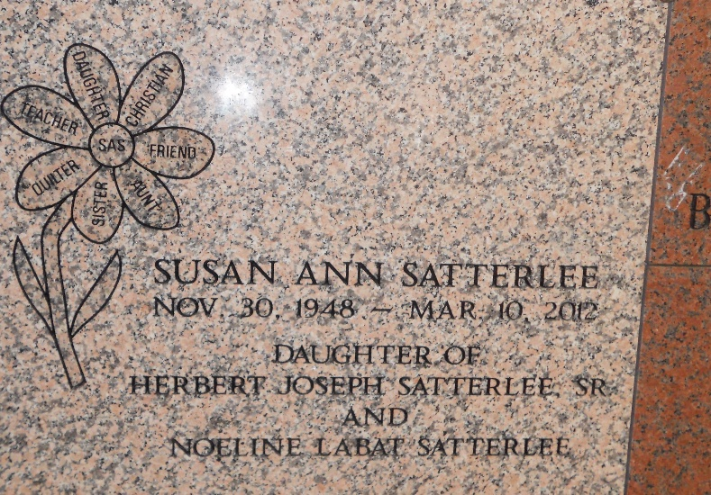
Photo by Team T-Lo

Susan Satterlee graduated to her home in heaven on Saturday, March 10, 2012. She is the daughter of Noeline Labat Satterlee and Herbert J. Satterlee (deceased). She is survived by her siblings: Faye Mercer (Robert), Jane Charpentier (Faron), Tina Allen (Brian), Herbert Satterlee, Jr. (Kayron) and Lisa Satterlee. She was the loving aunt of eleven nieces and nephews and six great-nieces and nephews.

She was an avid seamstress and was past and current president of the Quilting Fans Quilting Club and long-time member of the Gulf States Quilting Association. Susan taught school for forty years in the LaPlace area so if you are reading this in the River Parishes there is a good possibility that you can thank her for the ability to do so. She was 63 years of age and resided in LaPlace.

Visitation is from 9:00 am to 10:45 am with services at 11:00 am at Millet-Guidry Funeral Home, 2806 W. Airline Hwy, LaPlace, La, on Tuesday, March 13, 2012 at the Funeral Home Chapel. Burial in St. Peters Cemetery in Reserve, La.

The Times-Picayune, New Orleans, Louisiana
March 11-13, 2012

