Helen (Brady) Savell
August 19, 1920 – November 13, 2004

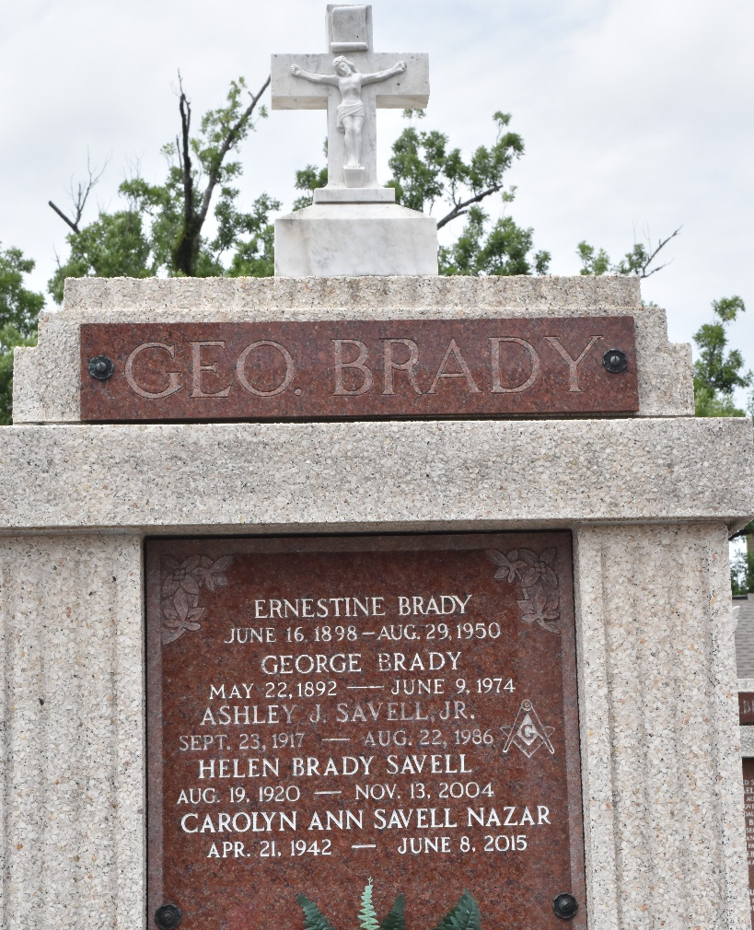

SAVELL

COVINGTON - Helen Brady Savell, 84, died Saturday, Nov. 13, 2004. She was a native of Taft, a resident of Arabi for 43 years and a resident of St. Tammany Parish for the past four years.
She was the wife of the late Ashley J. Savell Jr.; mother of Carolyn Nazar, Lorraine Lottinger, Ronald Savell and Judy Kehoe; mother-in-law of Paul Nazar, Frank Lottinger, Diane Savell and the late Michael Kehoe; grandmother of 11 grandchildren and 16 great-grandchildren. She was the daughter of the late George and Ernestine Desroche Brady.
Religious services are today at noon with visitation form 10 a.m. until service time at E.J. Fielding Funeral Home. Interment will follow in St. Peter Cemetery in Reserve.

The News Banner, Covington, Louisiana
Wednesday, November 17, 2004

