Gloria (Keller) Scallan
August 9, 1931 – February 14, 2016

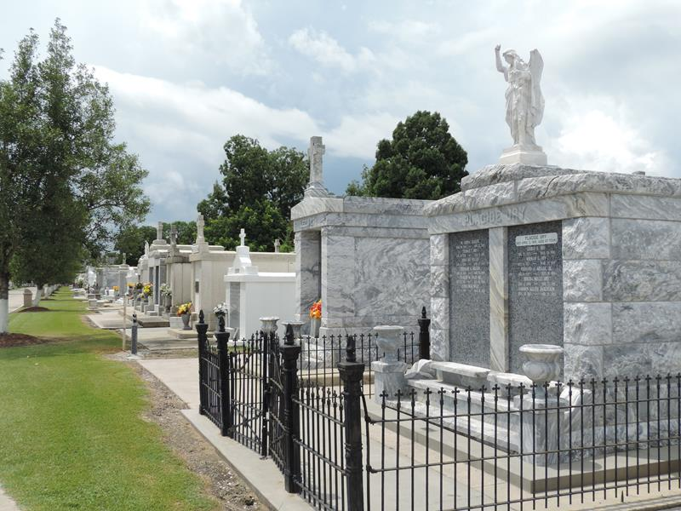

Gloria Keller Scallan passed away at 8:15 a.m. on Sunday, February 14, 2016 at Kindred Hospital in Clear Lake, Texas at the age of 84. She was a native and long time resident of Reserve, Louisiana and a resident of Pearland, Texas.
Beloved wife of the late Allen G. Scallan, Sr. Mother of Allen G. Scallan, Jr. of Houston, Texas, Dr. Perry Scallan of Blairsville, Georgia, and Barbara Glorioso of Pearland, Texas. Grandmother of Damon Scallan, Luke Scallan, P.J. Scallan, Jimmie Scallan, Carly Scallan, Jessica Rickley, Jennifer Sopczak and Austin Bryson. Great grandmother of Ashlyn Vaequez, Lauren Rickley, Lexi Davenport, Kameron Rickley, Kye Sopczak, Lincoln Wells and Ryker Wells. Daughter of the late Luke Keller and Joliette Jacob Keller. Sister of Helen Rousell, Lucres Milioto and the late John Keller, Anna Mae Tanquis and Lucille Millet.
Relatives and friends of the family are invited to attend the religious services at St. Peter Catholic Church, 1550 Hwy. 44, Reserve, Louisiana on Thursday, February 18, 2016 at 11:00 a.m. Interment will follow in St. Peter Catholic Church Cemetery. The visitation will begin at 9:30 a.m. until service time at St. Peter Catholic Church.
The New Orleans Advocate, Louisiana
Feb. 16 to Feb. 18, 2016

